**The Super Secret Nature Healing Society**

**By Rali Weaver**

**Dedicated to my wish daughters**

**Zoe and Lucy Carlson-Pietraszek**

Table of Contents

Chapter One 1

Beginnings

Chapter Two 13

The First Day of School

Chapter Three 22

The Super Secret Nature Healing Society

Chapter Four 30

Meeting Meemaw

Chapter Five 43

The Magical Healing of Bees

Chapter Six 52

The First Magical Potion

Chapter Seven 62

The Problem The First Potion Created

Chapter Eight 68

The Right Thing Can Make You Famous

Chapter Nine 75

A Very Wet Problem

Chapter 10 82

Shoo Fly Don’t Bother Me

Chapter Eleven 86

The Pathless Wood isn’t Really Pathless

Chapter Twelve 98

The Cycle of Life is Sometimes Sad

Chapter Thirteen 111

The Secret Place Everybody Knows About

Chapter Fourteen 122

Beauty Is More Than Skin Deep

Chapter Fifteen 134

You Are What You Eat

(If You Want To Be Smart You Have To Fart)

Chapter Sixteen 139

If You Can’t Beat Em’ Join Em’

Chapter Seventeen 148

The Sixth Key

Chapter Eighteen 159

The Not So Secret Nature Healing Shop

Recipes that Meemaw Taught To Margaret i-x

Chapter One

Beginnings

Ross and Margaret were both born at home, deep in the Adirondack Woods. Both of their parents and grandparents and even great grandparents had known each other their whole entire lives and yet none of those elder family members had as much in common at the time of their birth as Ross and Margaret did. Even so, they had always been polite to each other.

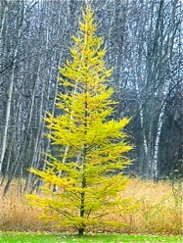

**A Tamarack Tree**

Quite strangely, on the morning that Ross and Margaret were born each of their families had just planted a tamarack tree. It was considered strange to everyone in those parts because planting trees of any kind in the Adirondack woods seemed a bit silly to most people because trees of every kind grow quite naturally in the woods and there isn’t any need to plant them.

The other strange similarity between Ross and Margaret’s birth is that according to the midwives they both took their very first breath at 11:11 in the morning. This might not have seemed so magnificent except that the day itself was November 11th, 1911, making their first breath at 11/11/11 at 11:11. That’s a lot of 11’s.

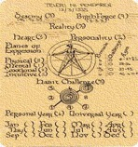

**A Numerology Chart**

Margaret’s Father was interested in the study of numbers called Numerology and he thought this number of 11’s was a mighty interesting phenomenon. You see, in numerology the number 11 usually suggests a deep spiritual awareness and an ability to inspire people without much effort. Not only that, but all those ones added up together make a number 10 which is reduced to be a 1 and usually means a new beginning of some sort. “If birth isn’t a new beginning,” Margaret’s father said to himself, “I don’t know what is!”

Margaret’s dad also knew that the number 10 for a birthday usually means that a person will draw attention and be very popular. Since Margaret was his first child he felt very excited to find out what type of person this new little baby would grow up to be.

Ross, on the other hand, was born into a family of 10 boys making him the eleventh son. Aside from thinking that it was a curious thing that Ross was their eleventh child and that he was born on 11/11/11 at 11:11, neither his mother nor his father thought much more about it. To them Ross was just another growing body that they were going to have to find some way to feed.

Other than the tamarack tree being planted and the curious number of 11’s in the time of their arrival, Ross and Margaret grew up in that mountain town in relatively normal ways.

As soon as he could walk Ross was out in the woods with his father and brothers hunting and trapping so that they could feed their large family. His mother taught him how to recognize what plants could be eaten and what ones could not.

Ross’ grandmother knew (knowing as older people seem to always know) that Ross was special. So she took him under her wing and taught him how to make homemade cures for just about everything that ails you.

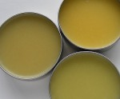

**Salves**

Ross’ grandmother, whom he called Meemaw made salves, which are healing balms that she created from pine oil and beeswax. She and Ross’ grandpa had both grown up with parents and grand parents and great grand parents who had kept bees. While most of the time the bees were for honey that they both ate and sold at the market, Ross’s grandmother had been gifted at a very young age with the ability to turn the wax into a wonderful healing medicine. She made salves to heal simple cuts and bruises, she made salves to soothe poison ivy and poison oak, and she made salves that would smooth out scars.

You name the ailment and chances are Ross’s grandmother had a salve that would make it better. People would come from as far as two towns away to get Ross’s grandmother’s healing salves.

Ross’ mother had hated growing up in that house with her mother’s cures and it had taken most of her life to learn to love home remedies. When she was small she wondered why her mother never offered the kisses her friends got on their boo-boos. When she was a teenager she was fed up with the salves her mother would rub on her every hurt and would laugh and make fun of her mother’s old-fashioned ways. But by the time that she had given birth to her eleventh son, Ross’ mother finally understood how much easier on the budget home remedies could be. She also appreciated having a place to send her youngest boy for several hours a day. So around about the time Ross turned two, she stopped making jokes about her mother’s salves and accepted whatever remedy she offered.

Ross loved it when he could spend the day at Meemaw’s house. He always brought her flowers that he picked on his nearly two-mile walk to her door. Sometimes Meemaw would take the flowers and, teaching Ross their names, would then pull them apart and use them in the salves she was teaching him to make. Other times she would put them in a vase to admire.



**Calendula**

She taught him that calendula was good for healing cuts, St. John’s wort was good for lifting people’s spirits, and Arnica was good for healing a bruise. Most of these things grew naturally on the path between their homes but once in a while Ross’s grandmother would have to write away and have a special root or plant or dried leaf sent from someplace else.

Now you might think it odd that a two-nearly-three-year-old would be able to make that nearly two mile journey to his grandmother’s house on his own, but up in the Adirondack wilderness letting a two year old loose in the woods wasn’t all that uncommon; besides, the path between Meemaw’s house and Ross’ house was well worn, nearly straight, and almost impossible to lose. All this to say as long as a person of any size stayed on the path and kept on walking they were bound to get to where they were going.

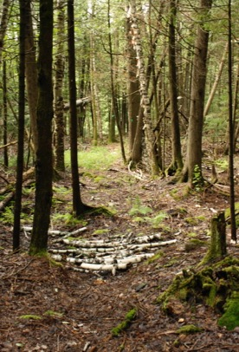

**The Well Worn Path Between Ross’ and Meemaw’s**

It was always worth taking that long journey. In the summertime Meemaw had the most marvelous garden in Essex County. It was filled with coneflowers and lavender and marigolds and chamomile and many other beautiful and good smelling plants he hadn’t yet learned the names of. There were paths through the garden beds and benches to sit on and little treasures such as wind chimes and statues hidden at every turn.

Each day that he visited Meemaw she would ask him to tend to the garden while she cooked him some breakfast and prepared the herbal tea for the day. Ross loved being in the garden by himself. He liked the smell of the earth and watching the new plants grow.

Ross learned to stay carefully on the paths between the rows of seedlings so that he wouldn’t hurt the plants or pack down the earth around their roots. As he worked he would pile the weeds into a cloth so he could take them to the leaf pile when he was through. Then Ross would take the big bucket next to the well and carefully water each plant, talking to them as though they were his best friends in the world.

Each day as Ross finished weeding and watering and talking to the plants his grandmother would come out of the house with a big tray of scones or eggs or buckwheat pancakes or popovers. Each day she would bring out some hot herbal tea, which they would drink later in the day iced.

Meemaw always surprised Ross by coming out of the house at exactly the same moment he finished his chores. He always suspected that she watched his progress out the window, but no matter how many times he tried to catch her looking he never saw her face at the window. One day he got up the courage to ask her how she did it. She seemed surprised and exclaimed that breakfast chores and outdoor chores must take exactly the same amount of time.

As you can probably tell this mixture of growing up in a large family and having to fight his brothers for each morsel of food, combined with the individual attention of being the youngest and getting special attention from his grandmother, made for a very happy childhood for Ross.

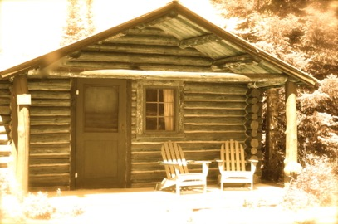

**Margaret’s House**

Margaret, on the other hand, grew up in a very small and lonely house. Six months after she was born her mother developed pneumonia and died. Pneumonia is a bacterium that gets into your lungs and gives you a high fever and a cough. It is a far worse cough than the kind you get with the common cold.

“People don’t always die from pneumonia,” Margaret’s grandmother later told her. “Its just that your mother was malnourished.” She went on to explain that ‘malnourished’ means a body doesn’t have enough vitamins from food. Since her mother’s body didn’t have enough vitamins the pneumonia had a chance to grab onto Margaret’s mother’s body in a way it wouldn’t have in a healthy body.

Margaret was too young to feel much of anything about the loss of her mother. However, Margaret’s father was very sad at the loss of his wife and so, while he tried to heal his heart, Margaret went to live with her maternal grandmother. In fact, she called her grandmother Mama for the first few years of her life, but then on her third birthday her father came and gathered her up and explained that she was his and her true mama had died when she was a baby. This didn’t make much sense to Margaret until she was older, but it was something she rolled around in her head even way back when she was three.

When Margaret’s father got her home he didn’t really know what to do with a little girl— so winter, spring, summer, and fall he would put her outside after breakfast and tell her to come back for lunch by noon. He explained that it was noon when the sun was straight overhead.

Fortunately, Margaret was born to love the Adirondack woods. In that summer when she was three she would have entire days where she would follow the path of a butterfly or bumble bee with joy until she noticed the sun straight overhead. Then she would find her way back to her house where her father would be waiting with lunch.

At lunch Margaret’s father, who worked from home as a book editor, taught her letters and sounds and how to put them together into words. Before her fourth birthday Margaret could read quite easily and without much effort.

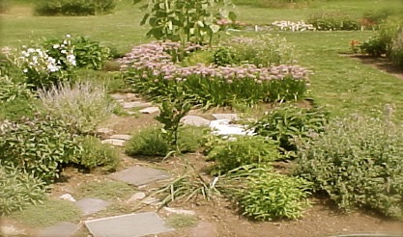

**Margaret’s Herb Garden**

Margaret also found that she enjoyed stirring about in the earth. Her father got her a book about healing plants and a few garden tools and Margaret set about landscaping all around their house. She planted flowers that the book told her were healing. She planted lemon balm and comfrey, nettle and calendula, jasmine, lavender and valerian.

As the plants and Margaret grew, she taught herself to make teas and salts for bathing and for cooking. Her father’s mood benefited from her trials. St. Johns wort tea left him feeling more hopeful, and the valerian root bath she made him take every night helped him sleep. “Margaret has a natural healing ability,” her father would tell anyone who would listen.

Sadly, taking care of her father in that way when she was just three and four years old left Margaret feeling very alone. “Who,” she thought, “is going to take care of me?”

Around her fifth birthday Margaret started going off deeper into the woods by herself to gather some of the roots and nectar that grew locally. This concerned her father a great deal, but since she always turned back up right at lunchtime he decided to try not to worry about it.

It was on a woodland excursion when they were both five that Margaret and Ross first bumped into each other, and that is where our story really begins.



**The Adirondack Wilderness**

Chapter Two

The First Day of School

Early on the morning of her very first day of school Margaret woke to weed her gardens. She gathered blackberries from the bushes that hung at the backside of the barn and, plopping a few into her mouth, caught the tamarack tree out of the corner of her eye.

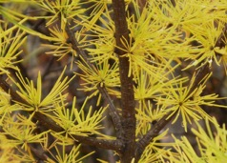

**The Branches of the Tamarack Tree in Fall**

She knew the story of the tamarack tree that stood in her yard and how her father had planted it on the day she was born. She had watched it grow, marking her own growth in its shadow. What seemed most unusual to Margaret about the tamarack is that although it looks like an ordinary pine tree that should stay green all winter, in the autumn the leaves change from blue green to yellow and fall off in the same way that leaves fall off maple trees and birch trees and oak tress. Margaret loved to mark her own development in the seasons of the tamarack, and so she sat with her handful of blackberries at the base of its whispery frame and contemplated her first day of school.

Margaret’s first ever day of school seemed like a mighty big development in her life and she felt both excited and scared to begin. These mixed feelings were a bit confusing to her five year old heart and so she sat eating a blackberry breakfast and telling the tamarack tree all about it.

As she talked she felt the Tamarack listen and didn’t doubt that it was. Knowing that the Tamarack understood her confusion left Margaret feeling more connected and less alone. As she finished the blackberries, her father called her from the back door and instinctively she hugged the itchy branches of the tree. She felt the soft leaves brush her face and she knew at once that the Tamarack tree was watching over her. Then her father handed her a paper lunch bag and she started off to the schoolhouse.

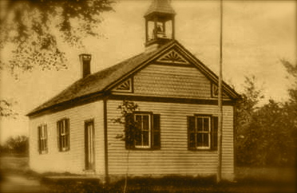

**The Adirondack Schoolhouse**

Ross, on the other hand, had no time at all for reflection before he headed off to his first day of school. With six older brothers in the elementary school he simply had to get in line for breakfast and grab a lunch and follow them to the schoolhouse where he figured he would learn to read and write and add and subtract.

All in all that first day of school was unremarkable. The kindergarten teacher, who was named Mrs. Fiske, was a tall dark haired woman with a musical voice. She had a nice smile, too, and the children in the kindergarten class fought to be near her during recess and reading time because of her warmth and kind heart.

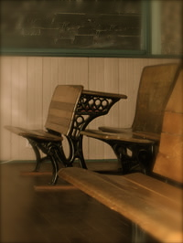

**Inside the Schoolhouse**

Neither Ross nor Margaret noticed each other that first day in school because Margaret’s last name put her toward the front of the class while Ross’ put him in the middle. And anyway, that first day of school was mostly a time to give Mrs. Fiske a chance to get to know all of their names and learn what each of them knew already.

Margaret didn’t let on that she knew how to read. She just wasn’t sure how this teacher (who was asking her to recite her A, B, C’s) would react if she knew a five year old could read whatever she liked and understand it. So on that first day Margaret answered just the questions Mrs. Fiske asked. As the seat assignments were changed to put the more “gifted students” toward the front of the class, Margaret was given the very first seat.

The way Mrs. Mabel Fiske saw it, her job as teacher was to roam around the room and help all of the students equally. She put the more advanced students in the front rows so she could keep them from getting bored while she helped other students to catch up. Several times a year she would move students based on their skill level. Very few students kept the same seat all year. Ross found himself somewhere in the middle of the room and in need of support both from his peers and from the teacher as he learned his letters and how to write them. For Ross that first day of school was an eye opener. He heard and saw things he had never even considered and realized that he had a great deal to learn.

When the bell rang at 3:00 all of the students instinctively rushed to put their pencils inside their desks and to sit up straight so that Mrs. Fiske would dismiss them. When the bell rang Margaret, who had long since finished with her work, was the first to line up and Ross, who was still trying to perfect the letter ‘A’ on his practice sheet, was last.

As soon as they were outside in the beautiful autumn day all of the students scattered in separate directions. Ross’ brothers set off with their friends down the street. Margaret and Ross both found themselves wandering toward the edge of the wood that lined the back of the schoolhouse and connected them both to their homes (that is, if you didn’t mind a shortcut through a pathless wood).

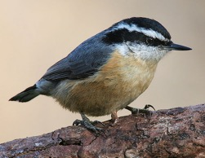

**A Nuthatch**

It was there inside the pathless wood that Margaret and Ross first bumped into each other. They really did bump. After a long boring day in school Margaret found herself in love with a sweet little nuthatch with its striped black face, blue gray wings and yellow belly. She was chasing it from the maple tree at the back of the schoolhouse straight to its nest. Her eyes were fixed on the bird’s dapper appearance and so she did not notice the other human in her path.

Ross was busy tracking the footprints of a wildcat. His older brother Oscar had told him that the wildcat is also called a lynx. Oscar had shown him that the footprints had a sort of upside down w at the bottom of the big pad of the foot and a dip like a v at the top. Ross had first noticed the print in the mud as he stepped just inside the woods. He imagined that the print was from a fairly young lynx because it was rather smaller than the one that Oscar had pointed out to him. Ross had just leaned down to look at the print more closely when Margaret came bounding over the shrubbery beside the muddy clump, chasing after her nuthatch.

“Ow, what are you doing?” Ross screamed as Margaret clumsily stepped on his hand. “Oh my! I am so sorry I was just chasing after this nuthatch,” Margaret responded with a gasp, pointing at the little bird. Margaret stopped to be sure this boy she had bumped into was ok, but to be honest, she was feeling torn between caring for his hand and continuing after her bird. “You should try to watch where you are going,” Ross scolded. “You never know what you might bump into in these woods.”

“Why were you hiding behind that bush?” Margaret accused, because she didn’t much like being scolded by a boy who was no bigger than herself.

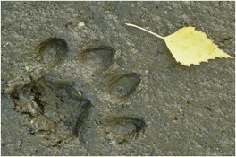

**A Wildcat Footprint**

“I found this wildcat print, and I was trying to get a closer look,” Ross explained as he pointed to the area he had been examining and then watched as the strange, little, strawberry-blond, curly haired, girl leaned down to take a closer look.

“Really, a wildcat?” she asked with excitement in her voice. It was in that exact moment that Ross realized he had found his first real friend. Nobody had ever been as excited by finding scat or a footprint in the woods as he was. To his brothers it was old hat. To his father it was childish business. Most of the boys he had met that day at school seemed bored when he was talking about the wild animals he had seen. But this girl was different.

“Yes,” he said confidently. “You see this print here, it’ s from a wildcat, or my brother says it’s properly called a lynx. See, it has this W in the bottom of the pad of the foot and a sort of V at the top. That’s how you identify it.”

Margaret took this all in while she looked closely at the footprint. “I never realized you could tell the type of animal from the footprint it left,” she said with astonishment. “Can you tell other animals this way?”

“Sure,” he said. “You can even identify some birds this way, although I haven’t memorized that many birds. I know because my Meemaw has a book with animals and their prints in it.”

“Oh wow! I have never seen a book like that,” Margaret said with excitement.

The rest of the afternoon went on that way: Ross pointing out what he knew about scat (wild animal poop) and foot prints and Margaret taking it all in. Now and then, Margaret would get distracted by a leaf she needed to make a good tea or a pretty flower and would stop and tell Ross all about it.

They walked together in the general direction of their houses until they both realized they would be late for supper if they didn’t hurry.



**Nasturtiums**

“Hey lets do this again tomorrow!” Margaret blurted out with enthusiasm.

“I would love to,” Ross replied sincerely. “I’m Ross O’Leary, by the way.”

“Oh, and I’m Margaret Appleby. I live with my dad just over that ridge,” she replied.

“I live with my mother and father and ten brothers just through that meadow,” he said with a smile. “Nice to meet you.” They both said at the exact same moment and laughed.

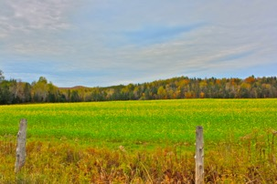

**The Meadow between**

**Ross and Margaret’s Houses**

They agreed to meet back in that spot the next morning an hour and a half before school to see what they could find on their way to the schoolhouse. Margaret promised to bring their breakfast.

As Margaret scrambled over the hill into her back yard she saw her Tamarack tree and she quickly told it all about that first day of school and how wonderful it was to have a friend. Then she skipped inside for dinner and to gather up some things she wanted to be sure to give Ross on that following day.

Chapter Three

The Super Secret Nature Healing Society

The next morning as Margaret came over the hill into the clearing behind Ross’s house she heard a trilling like a bird. The “coococachoo” echoed off the cliffs nearby. She knew it was not like any bird she had ever heard and she looked around wide-eyed to find that it was Ross making the sound. He smiled as she saw him.

“What are you doing?” she asked.

“Oh, that will be our secret call,” he explained. “The way I see it, you and I are starting a new club and we will need a secret call and a secret handshake.”

Margaret, who had never spent much time with other children, didn’t know anything about secret handshakes but she did know about keeping secrets. She kept the secrets of the blue jay’s nests and the humming bird’s nectar. She was good at keeping secrets. But a secret call and a secret handshake, well this was something new to her and she couldn’t wait to hear what Ross had in mind.

“So you see,” he began to explain, “when we are supposed to meet up, as we did this morning, we can make that bird-like sound and the other one of us will know where we are.”

Margaret smiled with understanding and asked, “So what’s a secret handshake for then?”

“Well that is more for fun. My brothers and I do this one.” Ross said as he began a complicated system of hand shaking and elbow bumping with Margaret. “We can make something up that is all ours,” he said when he was finished, “and it can be like our private way of saying hello.”

Margaret agreed although she didn’t much understand the logic of this, and said, “Maybe we should wait till after school to do that.”

Ross agreed and they headed off adventuring. They had a whole hour and a half till the bell would ring so they had plenty of time to explore the woods before heading to the school door.

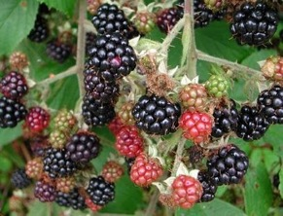

**Blackberries**

Along with the breakfast of blackberries and toast, Margaret had brought three things for Ross. First, she brought her favorite book about flowers and vegetables. They sat down near the big oak tree in the middle of the woods eating breakfast as she explained the pictures and read what it said about them.

Ross was surprised that she was such a good reader and felt a bit embarrassed that he didn’t know his letters yet. Not that Margaret noticed. She read all the descriptions without even stopping to see if he was keeping up. Ross liked that about her because it didn’t feel like a test. She just wanted him to know what she knew. He felt the same way.

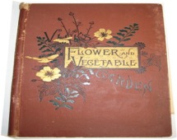

**The Book About Flowers And Plants**

When she was done showing him the pictures and reading him the words Margaret said, “You can keep this for as long as you like. I have this book memorized.” She smiled and handed it to him.

Ross was startled and didn’t know what to say and blurted out,“ Oh well, won’t do me much good, I can’t read.”

Margaret looked startled too. She wasn’t sure what to say, so she went back to the pile of things she brought for Ross and ignored his protest. “I also brought you this compass. I have two of them. Compasses point to the North, South, East, and West. It’s good to have if you get lost in the woods. If you know which direction your house is you can find your way home.”



**A Compass**

Ross smiled because he knew what a compass was. He didn’t have one but his older brother Michael did. “You sure you can spare it?” he asked.

“Why yes, yes,” she said with enthusiasm. “Like I said, I have two and anyway it will be important for our work as club members.”

Ross smiled because he realized he had decided that they were a club without even asking Margaret, and she seemed to like the idea anyway. “Thanks,” he said. “You’re right, a compass will come in mighty handy.”

Margaret was shy about bringing out the third thing she had brought. She was so excited about having a new friend, she had added it to the pile without ever thinking about whether or not Ross would understand its significance or think it was useful. She had been surprised that he said he couldn’t read, and was glad he was happy about the compass— she didn’t want to offend her only friend. But she had told him there were three things and he was waiting so she figured she had better just go ahead and give him the last thing.

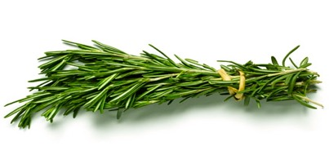

**A Bundle of Rosemary**

“The third thing is a bit silly,” she said with embarrassment, “but you said yesterday that you thought the school day was pretty long and you were having trouble paying attention. I grow this rosemary in my garden and I’ve got loads of it, and it helps to breathe it in when you get bored or can’t really pay attention any more. It smells good and might help.”

Margaret spoke rather rapidly and handed him the bundle of rosemary and Ross put it to his nose. “Wow, that does smell good,” he said happily. “My Meemaw makes cures for stuff, too, only hers are usually greasy salves and she doesn’t much work on cures to pay attention just ones that fix physical problems,” Ross said with a laugh. “I actually brought you something, too. I noticed yesterday that you had a bit of poison ivy on your ankle and this will clear it right up.” Ross handed her a little glass jar with some of his Grandmother’s poison ivy remedy. Margaret laughed.

“What’s so funny?” Ross asked.

“Well, I thought you might be offended that I was giving you stuff to help you pay attention and you had a cure of your own to offer me all along.”

After that neither Margaret nor Ross thought much about helping the other one out with anything. In fact, that day in school when Margaret would finish something she would look back at Ross to see if he needed help. Once he shook her off because he was really trying to figure some math problems out on his own, but the rest of the time she wasn’t busy he motioned for her help. It wasn’t long before Mrs. Fiske caught on and realized how far ahead Margaret really was, asked them if they wanted to work together, and moved Margaret’s seat to the middle of the room so she could sit beside Ross and help other students as well.

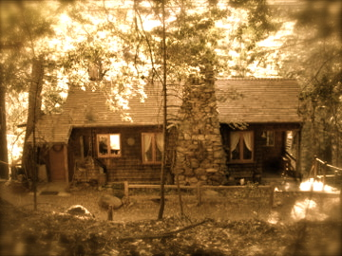

**Ross’s House**

Every day of that very first week of school pretty much went like this with the “Super Secret Nature Healing Society” meeting in the woods before school and the two new friends wandering back home barely making it in time for dinner. Ross and Margaret had countless things to talk about and show each other and when they weren’t teaching each other what they knew they would sit under the blanket of trees and Margaret would help Ross practice his reading. Reading, they both decided, was a very important skill to have in order to conduct club business.

When the end of club time came on Friday Ross and Margaret said goodbye for the weekend and set off to their homes for dinner.

Chapter Four

Meeting Meemaw

Margaret, who loved being at school with other children, was disappointed when Saturday came because she was home alone again.

Ross, on the other hand, was looking forward to a day at Meemaw’s house. But when he woke up that Saturday morning his first thought was of Margaret. He wondered what she was going to do with her Saturday and so he decided to slip out early into the back woods behind their separate houses and see if their secret birdcall really worked.

Margaret, who had cooked breakfast and cleaned the kitchen while her father was still asleep, went out to work in her gardens and talk to the Tamarack Tree. She told the Tamarack tree how much she missed school and how she hoped that Monday would hurry up and come. Just as she was about to weed her gardens she heard a familiar trilling in the woods behind her house. She knew right away that it wasn’t a bird and smiled to herself thinking that the Tamarack had really listened and called Ross to her. As she climbed atop the knoll at the back of her yard she immediately saw Ross’ dark black hair and made her own attempt at a “coococachoo” back to him.

Even from that distance she could see Ross smile as she ran, tripping over every tree root to get to him. He laughed to see her hurry and asked as she came, “What are you up to today, my sister healer?”

“Oh, I was just playing around in my garden,” she said lightheartedly. “Want to come see it?” Ross nodded and they headed over the hill into Margaret’s yard.

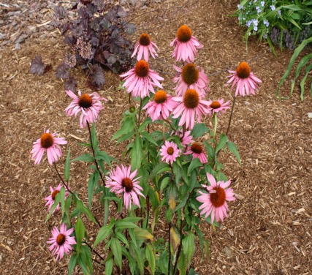

**Margaret’s Echinacea (Cone Flower)**

She took him on a tour and showed him all her flowers, and while they toured they both pulled weeds and watered plants and before she knew it her garden was ship shape again.

When they were finished Margaret asked Ross if he had eaten breakfast. He said he hadn’t but was hoping he could convince her to join him for the day at his grandmother’s house.

By this time Margaret’s father was awake. He had never seen his daughter with another child, and he stood watching them from the kitchen with wonder. He decided to go outside and ask Margaret about her friend.

Margaret giggled when she heard her father’s question because she realized that while she had told the Tamarack tree all about Ross she hadn’t mentioned a thing to her father. “This is Ross, Dad. He is my friend from school.”

Ross laughed and said to Margaret, “I’m your friend from the woods.” Then he turned to Margaret’s father and said, “Glad to meet you,” with an air of someone much older than five. “I am Ross O’Leary. I live just over that knoll and through that clearing. I was hoping I could take Margaret with me today to visit my grandmother. She lives over in Haley Hollow. I usually go there on Saturday’s to help her around her house.”

Margaret’s dad smiled and said, “Well that is up to Margaret.” Turning to Margaret he then said, “Do you want to go?”

“Yes!” she said enthusiastically.

And off they went. The road from Margaret’s house to Meemaw’s was a bit steeper and less defined than from Ross’ house but both of them, knowing how to use a compass and being such experienced hikers, and using their compasses, had no difficulty navigating their way to Meemaw’s back door.

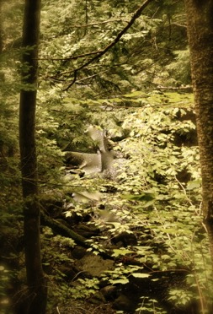

**The Path From Margaret’s To Meemaw’s**

Ross had not told his grandmother that he was bringing a friend and at first he thought he should tell her before they started working on her garden, but Margaret said she had already eaten breakfast so they got right to work.

Ross watered while Margaret weeded. It was such a beautiful day; the sun was shining over the mountains and the sky was as blue as the cornflowers that grew along the forest edge. There were a wide variety of butterflies everywhere and Margaret wondered what attracted them. The beauty and the soft breeze made weeding and watering a happy experience and before they knew it they were finished.

Since they were finished in half of the time and still had time before breakfast, they started to rake and weed the gravel walkway that lead to the dirt road. Ross had wanted to weed that driveway for his grandmother for many months, but thinking about weeding the entire driveway seemed too big a job to do with just one pair of hands. He was surprised how quickly everything went when there were two people to do it and he felt grateful for Margaret’s help.

They had raked and weeded the entire driveway when Ross’ grandmother came from the kitchen. She smiled when she saw Margaret because she knew immediately whose daughter she was. “You must be Margaret Appleby,” she said. “I am Ross’ Meemaw, but you can call me Mary if you want.”

Ross was startled and thought he would have to remember to ask her how she knew who Margaret was. They all sat down at the table together and Meemaw offered Margaret some tea and a hot scone. Margaret said she had already eaten breakfast but smelling the hot buttery delicious biscuit-like cake, she changed her mind. Ross noticed that his grandmother had curiously made three extra scones that morning so there were plenty for everybody.

Over breakfast they talked all about gardening and home remedies and nature. Ross told Meemaw about Margaret’s Garden; Margaret told Meemaw about how quickly the poison ivy salve had cleared up her rash; and Meemaw told them both about what she had planned for that day.

After breakfast they all cleaned up together and then headed to the woodshed behind Meemaw’s house. In front of the woodshed there was an enormous pot sitting in a fireplace. Meemaw explained that they were going to make a salve for aches and pains.

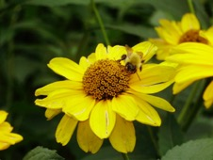

**Meemaw’s Arnica**

Margaret already figured they would be using arnica, which she was familiar with, but she had no idea how to put healing ingredients into a salve and she was excited to find out.

Ross, on the other hand, already knew what to do. He went into the shed and pulled out big blocks of bee’s wax, which he put into the pot. His grandmother made a fire beneath the pot while he went back to the shed to get pine oil. While he did all the heavy lifting Margaret asked Meemaw how she attracted so many butterflies to her garden.

“Well, first of all, my garden is very old and so these butterflies and their families have been visiting this garden for generations.” Meemaw smiled because she loved the butterflies too. “It helps that I have so many plants that attract the butterflies, too. Butterflies and healing salves need many of the same ingredients.” Meemaw started to pick up each of the plants on the table and tell Margaret about them. “The caterpillar that becomes a painted lady butterfly needs burdock to put her cocoon in, and I need burdock root to help cleanse blood and prevent infections,” she explained as she picked up a brown root and handed it to Margaret.



**Meemaw’s Butterflies on Echinacea Flowers**

Margaret didn’t know about caterpillars and cocoons and had many questions, but Ross had just come from the shed with the last of the ingredients so it was time for a different lesson.

“Meemaw should I add another log to the fire?” Ross asked, and Meemaw nodded and then turned her attention to the salve makings.

“Here we go, Margaret, grab that big spoon.” Meemaw pointed to the biggest spoon Margaret had ever seen. It was wooden and handmade and was quite heavy. “We add 1 part wax to 8 parts oil. I made this oil from the pine trees in the area. I filter it 2 times so it doesn’t’ have much smell. Then I soaked Arnica flowers in it for the salve we will make today. The bee’s wax comes from our bees that are behind the barn. This afternoon after lunch I can teach you how we make the oil.”

As soon as the bee’s wax began to melt Margaret started to stir as Ross added the oil. When the wax was melted into the arnica infused oil, the two-helped Meemaw to ladle it into small jars for selling. Ross showed Margaret the tricks so they wouldn’t spill it while ladling it into the jars. Once the jars were full, Ross and Margaret carefully put the lids on so as not to burn themselves and, once they had cooled, put Meemaw’s labels on so people would know what type of salve was in the jar. When they were finished they had 47 little jars to sell, which they carefully place on the shelves in the shed for the next time they went to market.

Margaret was thrilled with this process and couldn’t stop asking Meemaw questions. “How long will jars that size last a person?” “Could you make the same salve with lavender to help a person sleep?” “What if someone is allergic to pine?” Meemaw tried to answer each question as it came, but Margaret was so enthusiastic she could hardly stop asking. Finally it was time to sit down for lunch.

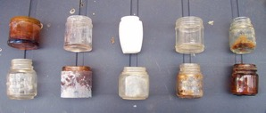

**Salve Making Supplies To Be Cleaned**

As he and Margaret cleaned up the salve making supplies Ross’ Grandmother laid out the table with the best looking cheese and fruit and meat and salads. To Margaret this looked like a feast. Her lunch meals usually were just a piece of fruit and a sandwich, and this smorgasbord was more than she had ever dreamed of. There was rice salad that tasted of cilantro and olive oil. There was fruit salad with whipped cream and mint. There was sliced turkey and ham and three types of bread and four types of goat cheese and honey and iced tea. Even though Margaret didn’t know where to start eating, her questions stopped as soon as she got to the table and they all ate in relative silence until Meemaw started to describe what they would do that after lunch.

“This afternoon I am going to show you how we make the pine oil,” Meemaw explained. Margaret was thrilled to hear it. “We will start by gathering pine bark from fallen trees in the woods. You both know how to identify a pine tree, don’t you?”

Ross and Margaret nodded with their mouths full. One of the first things they had talked about in their “Super Secret Nature Healing Society” was what tree was what. They already knew that there were about one hundred and fifteen types of pine trees in the world and that they were evergreens and had cones on their branches and that their bark was sort of thick and scaly. Meemaw explained that some pine trees lived to be as old as 1000 years and could grow taller than two hundred and eighty feet tall.

Meemaw explained that she wanted as much bark as they could get, but she wanted them to take it from trees that had already fallen because she did not want to shorten the life of any tree just to make some oil.

When they had finished eating Ross and Margaret headed into the woods to collect pine bark. At first it was hard. Ross had watched his grandmother do it before but cutting through the thick spindly bark was difficult. Soon, though, they realized that the bark had an easy way to cut and a hard way to cut. Margaret remembered reading a description of “cut with the grain” and realized this must be what it meant. Once Ross and Margaret ‘cut with the grain’ along the bark of the downed pine trees it wasn’t long before they had filled the two wheel barrows and were on their way back to the house.

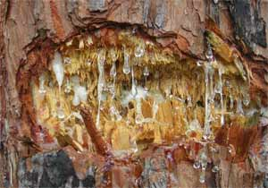

**Pine Bark and Sap**

Ross and Margaret were covered in pinesap and smelled so good. Meemaw suggested that they go wash in the brook near the house before it got too stuck and so they did. That autumn afternoon was warm and sunny, and it felt glorious to slide down the steep hill and into the water. Ross and Margaret splashed each other and scrubbed the sticky spots until they were all clean. When they headed back to the house they found that Meemaw had just finished preparing all the pine bark in the large metal pot with the hole in the bottom. Margaret wondered how this was going to work.

Meemaw had cut all the bark to fit into the pot and then coiled the bark into a tight mass inside the metal pot. She had Ross and Margaret affix the lid, which sat tightly upon the top of the pot. Then she had them burry a smaller pot at the bottom of a hole. Margaret listened closely to the directions because she had no idea what would happen next. After they had buried the smaller empty pot that had no lid, Meemaw had them place the bigger pot with the lid over it, making sure the holes on the bottom sat over the little open pot. Then she told them to burry the bottom fourth of the big pot in the dirt. Margaret explained to Ross how much one quarter was. “It’s like you divide the pot into four pieces and then you only cover one of them,” she said.

Once they were done Meemaw started a fire around the pot, and covered the pot with burning embers. Margaret realized how hard it would be to make the oil without a grown up to tend the fire. She was sorry when Meemaw told them that the rest of the oil making would take four or five hours and she realized that she would have to go home before it was finished. Meemaw explained that the heat around the pot pulled the oil out of the bark and it would drain down into the pot below and the reason that they had buried the pot below was because oil is very flammable and burying it keeps it from burning up.

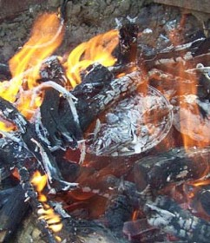

**Fire Around the Pine Bark Filled Can**

While the fire began its work, Meemaw gave Margaret and Ross bundles to take home. Margaret’s was full with four different types of salves, three bars of sweet smelling soap, two of the scones from breakfast, and two of the cookies from lunch. Ross’ bundle was full of things for his mother, and a jar of the salve that they made that day, and cookies for all his brothers. When Margaret and Ross gave Meemaw hugs as they headed toward the gate, Margaret thought she had never had a more fun day in her life. “I hope I can come back sometime soon,” Margaret blurted out before realizing inviting herself might seem sort of rude.

“Of course you must come, Ross, any friend of yours is a friend of mine” Meemaw said with a smile.

Ross laughed and said “Margaret is my best friend so can she come next Saturday, too?”

Meemaw exclaimed “So long? I was hoping you two would come tomorrow and see how this pine oil turns out and help me with the bees.”

And so the plan was made to come the next day. In fact, from that day forward, every weekend they would come together to help Ross’ Meemaw.



**The Mossy Path From Meemaw’s House**

Chapter Five

The Magical Healing of Bees

Margaret could hardly sleep for thinking of going back to Meemaw’s house the next day. Suddenly her lonely weekend had turned into an educational one. She had learned more about the things she was interested in with Meemaw on Saturday than she had all week long at school. Needless to say, Margaret got up very early and weeded her own garden and, with the scones that Meemaw had sent her home with, prepared breakfast for her father just in time for Ross to come over the hill with his “coococachoo.”

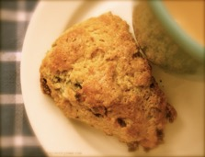

**Scones for Margaret’s Father’s Breakfast**

When Margaret heard the secret club call she was in fact sitting in the yard talking to her Tamarack Tree and ready to go. Her father already knew the plan, so all she had to do was wave good-bye to the Tamarack and head up the hill to find Ross. He was easy to spot. For some reason he had worn a bright yellow shirt which made him stand out in the woods. Margaret who was wearing the green brown color of the woods, easily snuck up behind him and startled him.

“Oh, Margaret you better stick with me today,” Ross blurted out. She wondered why and he explained before she asked. “Today is the start of the hunting season for deer and you might blend into the woods and get yourself shot in that green and brown dress.”

Well, that explained Ross’ yellow shirt! She thought about going home to change but decided that Ross was so bright that staying close to him would work just as well. It wasn’t long before they were at Meemaw’s house and working on her gardens. Because they had already raked and weeded the driveway the day before, when they were finished they had plenty of time to run around and play a bit before breakfast was ready. Except for Ross, Margaret had never really had a friend to play with so Ross had to teach her about tag and hide and seek. She caught on quickly and they had loads of fun.

Because it was Sunday, breakfast was made up of popovers and honey and eggs and bacon. Margaret was surprised by the popovers, which were a soft eggy roll. They were hot and Ross taught her how to smother them with butter and honey. Margaret thought they were the most delicious things she had ever eaten.

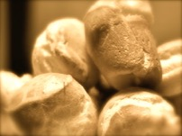

**Popovers**

When they had cleaned up after breakfast and Ross and Margaret were helping Meemaw to wash the dishes Margaret impulsively asked, “Do you think you could teach us to bake like you do?” Meemaw said, “Of course, I would love to. Let’s ask your father and Ross’ mother if you two can come earlier in the morning next Saturday and we can start your lessons.”

Margaret was thrilled. She liked Meemaw instinctively and felt she could never have found a better teacher. “Do you think you could teach me about nutrition too?” Margaret asked. Meemaw was surprised “I could, but why do you ask about nutrition?” Margaret explained that her mother had died from pneumonia because she was malnourished and that she had read a few books about proper nutrition but she couldn’t quite make sense of what those books about nutrition had to do with real food. Meemaw understood that Margaret and Ross had a desire in their heart to do things to make people well, and since Meemaw had always had that same desire she was excited to teach Ross and Margaret everything she knew.

Meemaw took Ross and Margaret over to the burning pit where they had worked the day before. She let them uncover the pile. It had cooled overnight and was safe to touch. They dug out the top pot that held the bark and then pulled it out of the ground. Beneath it they found that the smaller pot was about three quarters full of oil. Meemaw then explained that they would filter the oil to make it as fragrance free as possible, but that some of it they could keep out and use as a cleaner. She explained that unfiltered the pine oil would kill germs and make things fresh again.

When they had finished clarifying the oil with the use of filters, Margaret could see that it was much clearer and had very little scent. This, she realized, was what they used with the beeswax to make the salve for aches and pains.

Meemaw then told them that they were going to work with the bees. She asked them what they already knew about bees. Margaret only knew that they loved to drink the nectar of her flowers and that if she got too close to them they stung her. Ross, who had grown up in a bee keeping family, added that the honey was the best tasting stuff in the world.

Meemaw told them that if a person ate the honey from a local bee, it would help them to fight allergies to local plants. She explained that allergies were what caused people to have reactions like sneezing and coughing or even spots on their skin when they came in contact with something their bodies didn’t agree with. Meemaw took Ross and Margaret to a big field of clover and showed them where the beehives were.

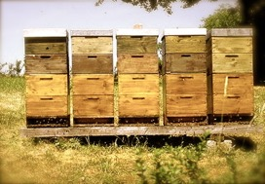

**Meemaw’s Beehives**

Before they approached the hive they went to a shed and put on a helmet and a net to cover their faces. Because Margaret was wearing a dress, Meemaw had her put on a pair of gloves and a pair of coveralls to cover her legs and arms.

Once they were all covered Meemaw showed them how to start a smoke fire in a pot to carry with them as they entered the hive area. The smoke seemed to lull the bees so that the humans could get to the honey. Meemaw helped Ross and Margaret to pull out every other honeycomb frame and put them in a cart. Once all the honey and wax was harvested they rolled the cart back to the shed.

Back safe in the shed, they pulled the honey-dripping frames out of the cart and placed them on grates. Meemaw taught them how to cut the wax from the frame leaving a bit along the edges for the bees to work with to make some more. Then she helped them cut the wax into manageable sections and lay them to drain so that the honey could be collected and the wax would be left to use for salve. Once all the frames had been cleared of all but the thin strip of wax along the edge, Meemaw helped Ross and Margaret return the frames to the hive.

This all seemed so simple when working with Meemaw, but Margaret knew it would be impossible to do any of this herself. Sitting in the sunshine and looking at the draining golden honey and the bees hovering over the clover, Margaret pondered how many amazing and almost magical things bees made possible. Bees could pollinate the fruit trees so that they made fruit. Eating honey could keep a person from getting allergies. Mixing the honey in a tea could make a cold feel better. Using the wax could make all kinds of salves that could heal all kinds of ailments. What Magical Medicine Bees could make!

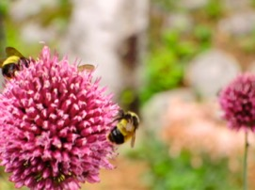

**Meemaw’s Bees on Chives in Her Garden**

Meemaw explained that there were many different sets of hives on the property. Five hives were set up by the clover field, three were set up by the fruit trees, and three more were set in wild flower fields. Each set of hives made different types of honey, and they all had distinctly different colors and flavors. Margaret couldn’t wait to taste them all.

After they had finished with the clover hives Meemaw suggested that Ross and Margaret head down to the pond to take a swim. It had grown so warm that morning that they both agreed with enthusiasm. Both Ross and Margaret had long white cotton undergarments under their clothes that worked just as well for swimming, and it wasn’t long till they were in their long underwear jumping in the clear water of the pond.

They had each learned to swim by accident, so they splashed around the pond without any real idea of strokes or form. Far from any other people, they could make as much noise as they wanted. Fortunately, the pond was so shallow that they could both stand with their heads above the water. There was a little dock that headed from the shore to the dead center of the pond. There were several old tire inner tubes to float around the lake. And finally there was a magnificent swing hanging from a giant Oak tree. The pond was a perfect place for young swimmers.

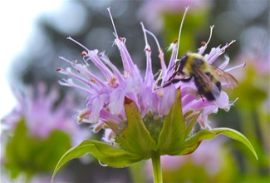

**Meemaw’s Bees on Her Bee Balm**

As they played Margaret noticed the bees nearby collecting pollen for their honey. She imagined they must be the wildflower bees because the flowers near the pond were Honeysuckle, Daisy, Verbena and Bee Balm. As she floated around the pond in the inner tube taking in the clouds bouncing around in the blue sky and the sweet smelling flowers in the field and the honeybees flitting about and felt the cool water on her hands and feet she was pretty certain this was the most magical place in the whole world.



**The Most Magical Place In The Whole World**

Chapter Six

The First Magical Potion

When Ross and Margaret returned to school on Monday everyone could see that their friendship had thickened. Mrs. Fiske felt she must keep a strict eye on them because even though they stayed focused on their schoolwork at all times, during unstructured times they clearly had much to talk about. Most of the other students kept their distance, recognizing that these two friends showed no sign of needing a third, but Freddy would not be so easily dissuaded.

Freddy was a sort of interesting case. To begin with, since he was a first year student for the second year in a row, Freddy Simpson was at least a head taller than everybody else in the class (except maybe Miranda Mosley who simply came from a tall family). Unlike Miranda who was as nice and as kind and as generous as a person could be, Freddy actually liked pushing his weight around and telling all the other kids what to do. When he happened upon Ross and Margaret on the playground that second week of school, he found a challenge he could not pass up. Two friends represent a bigger obstacle than one, so he decided that breaking them up would be fun.

Part of his favorite bullying technique involved quietly telling lies to one kid about another kid so that a rumor would start and everyone would be mad at someone and he would come off clean as a whistle. Sometimes, though, he would just threaten a smaller kid, tell him he was going to hurt him if he didn’t do something or other and that way Freddy could get the kid to write on the wall or get a boy to go in the girls room or a girl to go in the boys room and then Mrs. Fiske would be mad at the kid and not at Freddy. Freddy’s most regular prank was to get someone to give up his or her lunch everyday.

“With two friends that were as close as Ross and Margaret this would take a bit more finagling,” Freddy thought. And so for a few days he watched their habits. The first thing he noticed was that they were always talking about birds and flowers and footprints. It all seemed pretty industrious to Freddy and so he wondered, “How could footprints and flowers get someone in trouble?”



**Dog Print compared to a Blackbird Print in Snow**

Freddy decided that instead of getting them in trouble, the real trick would be to get Ross and Margaret mistrusting each other. The first thing he tried was to pull Margaret aside and tell her some misinformation about a footprint. “Hey Margaret, look here at this Blue Jay print,” he would say while pointing at a dog print in the schoolyard and she would look at it and say “Freddy, I think that is a dog print.” Then she would call Ross over and he would kindly agree and they would take Freddy over to see a real Blue Jay print and even point out the Blue Jay.



**A Blue Jay**

Next he went around the playground making wildcat prints with his thumb and collecting wildcat scat he found in the woods, trying to make it look as if there was a wildcat on the playground. He thought if Ross and Margaret alerted everyone to the dangerous wildcat they would all have to stay in for recess and at least everyone else would be mad at the two friends. Somehow, though, Ross and Margaret both agreed right away someone was playing a trick and that the wildcat prints weren’t real.

As a last resort after countless other attempts to get Ross and Margaret to disagree or fight or even get everyone mad a them, Freddy filled up a cardboard pint container with berries that he knew were poisonous and gave them to Ross and Margaret saying, “These are some extra blueberries that my mom said I could give to a friend. I know you like to bake, Margaret, so I thought you might want them.”

Margaret thanked Freddy kindly and they both walked away. Freddy thought his plan had worked.

Naturally, Ross and Margaret both knew right away that the blue berries in the carton were moon berries and were poisonous, but rather than confront Freddy right away they wanted to talk about it with Meemaw. In front of Freddy, Margaret said to Ross “Maybe we can take these to your Meemaw’s house and make blueberry scones or pie or pancakes.” and Ross agreed just as the recess bell rang and they went inside.

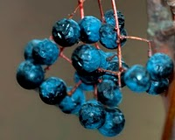

**Moon Berries VERY POISONOUS!!**

After school when Ross and Margaret were all alone Margaret said, “Why do you think Freddy did that?” and Ross wondered the same thing.

“Maybe we should bring these to my Meemaw and ask for her help,” Ross suggested, and Margaret agreed. So rather than their usual afternoon excursions in the woods they headed straight to Meemaw’s house after school.

She was in the garden when they arrived and for some reason was not at all surprised to see them. They both explained that they had something they needed to ask her. Margaret pulled the carton of berries out of her sack and showed them to Meemaw. She explained that Freddy Simpson had given them to her and that she knew they were poisonous and she wondered why he might do that. Meemaw asked what sort of person Freddy was and Margaret and Ross explained that he had stayed back a year and that while he had always been pretty nice to them he was the sort of person who seemed to like to get people in trouble.

Meemaw suggested that perhaps Freddy wasn’t being all that nice to them after all. She then helped them start a fire and burn the berries and took them inside to make a batch of blueberry scones with real blueberries to take to Freddy at school the next day. “You can catch more flies with honey than you can with vinegar,” she said.

The next day at school Ross and Margaret brought those blueberry scones right to Freddy. “Hey Freddy,” Ross said cheerily. “We brought you these blueberry scones. We didn’t make them with the berries you gave us cause they were actually moon berries, which are poisonous. You should tell your Ma to stay away from them.” With that Margaret thrust the scones into Freddy’s hands with a smile and they walked away.

Freddy was dumfounded. They didn’t even seemed mad at him. They made him scones. He was sort of afraid to eat them but as usual his Ma hadn’t packed him any lunch so he was conflicted about it. It was strange to Freddy that Ross and Margaret had acted as though he had given then the moon berries by accident and they didn’t seem mad at him at all. He doubted that they were trying to pull a fast one on him and give him moon berry scones instead. Still, he was relieved when after one bite he could taste the real wild blueberries. The scones were so delicious he gobbled the whole batch of scones down for lunch. Freddy liked the scones so much he almost decided not to pick on Ross and Margaret any more.



**Blueberry Scones for Freddy**

It was about this time that Ross and Margaret realized what Freddy had been up to all along and started watching Freddy’s every move. While watching birds, Margaret noticed Freddy teasing the twins. While collecting scat near the back of the school, Ross noticed Freddy forcing Ralph to give him his lunch. After school from the protection of the woods Margaret and Ross agreed that Freddy was a bully. What should they do?

Ross thought they should tell Mrs. Fiske, but Margaret thought maybe there was something they could do themselves. She asked Ross to give her overnight to think about it; he agreed, and they went their separate ways agreeing to meet even earlier before school to talk it out.

All night Margaret searched her books for herbs that might help make Freddy nicer. She considered St. Johns wort to lift Freddy’s mood and motherwort to encourage in him more passive behavior. She also knew that valerian root might help with sleeping and pain and black cohash could help calm a person. To really treat him properly, she thought, she needed to know exactly why he was behaving that way.

When she met Ross the next morning she suggested that they infuse the school water tank with a mixture of Motherwort, St. John’s wort, and black cohash. She explained that these three ingredients would calm all the students’ moods and make them all a bit calmer and more relaxed. She also suggested that they encourage all the other students to stop allowing Freddy to bully them by teaching them to come to each other’s aide and respond to his demands with questions like, “Do you think you are being nice when you treat us like that?” and “What do you think would happen if I told Mrs. Fiske what you just said?” and then just walk away. Then Margaret suggested that she and Ross keep a checklist for the rest of the week to see if they could come up with anything else they could do to help Freddy curb his bullying and be nicer to everyone.

Ross thought this was a brilliant plan because instead of just getting Freddy in trouble with Mrs. Fiske they might be able to stop him from bulling altogether. Ross volunteered to climb up to the top of the water tower before school and drop the giant teabags that Margaret had made in the school water supply. He had climbed up on a water tower before on a dare from one of his brothers so he knew he could do it. Still, he was a bit nervous since the water tank was out in the open in the field beside the school, and so Margaret served as a look out so that none of the teachers would see him.



**The School Water Tower**

As it turned out, when they got to school that morning they were so early that none of the teachers were even at school yet. It was a good thing, too, because the school’s water tower was covered in hornet’s nests and so instead of keeping an eye out for teachers Margaret had to keep her eye out for hornets. Thanks to her eagle eye and Ross’ agile climbing, their mission was accomplished without a sting.

The next thing they needed to do was get all the other students to agree to stop giving in to Freddy and instead to confound him with questions. Margaret was sure that even if the herbs in the water tank softened his mood Freddy would still bully people because it was a habit and they all needed to work together to help him break his habit.

So, as the students entered the school that morning, Margaret took them each aside and gave them little questions to ask Freddy when he started to push them around. Most of the students seemed really happy to have a solution to their problem. A few of the boys, though, acted as though they didn’t know what Margaret was talking about, but they agreed to go along anyway.

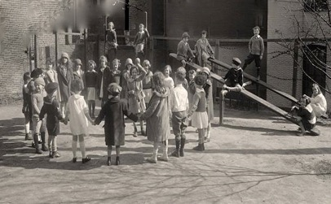

**School Playground**

At recess most everyone played a game of keep away together which didn’t give Freddy much opportunity to cause trouble, but when he did try to corner Edward for his lunch, Edward said, “Freddy, if I give you my lunch I won’t have anything to eat either,” and then just walked away.

Watching Freddy, Ross realized that he never had a lunch, and he wondered if he ever got breakfast either. So on the second day Ross offered Freddy part of his lunch and asked “Hey Freddy, how much are you getting to eat on school days?”

“Not much at all. My Ma says food is to have at home so she won’t send me with no lunch and I wake up so late some days I don’t get no breakfast.” And so it was that Ross started to make an extra breakfast and lunch for Freddy everyday. With food and friends and the magical herb potion Freddy was never a bully again.

Chapter Seven

The Problem The First Potion Created

It wasn’t long before all of the students, and even Mrs. Fiske, noticed a big difference in Freddy’s behavior. Having a good breakfast and lunch every day gave him very little reason to force his classmates to give up their lunches and drinking the herbal water took away any other anxious or upset feeling he was having. The only thing really left for Freddy to do was to make friends and do his schoolwork.

Even during class time Freddy was more focused and was able to start learning to read and write and add and all the things he had missed his first time through Mrs. Fiske’s class. Every recess you would find Freddy on the playground and instead, of pushing kids off the seesaw, he would be waiting in line for a turn. The other kids changed, too. Before you knew it, everyone was competing to sit with Freddy at lunch and to help him with his schoolwork when he was having problems.

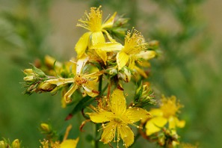

**St. John’s Wort**

That is everyone but Miranda Mosely. As Freddy turned more calm and cooperative since drinking the school water infused with Motherwort, St. John’s wort and black cohash, Miranda become absolutely silent. If you remember Miranda was already as nice and kind and as generous as a person could be, before unknowingly drinking the healing potion in the school water. After she drank the herbal water, she became absolutely quiet and standoffish and withdrawn.

Margaret and Ross didn’t notice this right away, but after a while it was obvious that when the other kids were playing Miranda was sitting by herself, under a tree, reading. When the other kids were eating lunch, Miranda was sitting by herself at her desk doing extra work.

Another day or two went by before Margaret realized that while Freddy was getting happier and happier it seemed lots of the other kids were looking more down in the dumps. They were still participating in all the activities, but some of them looked bored or unhappy. When they considered this after school Ross and Margaret realized that they were feeling pretty bored, too. That was when it dawned on Margaret that the problem was that not everyone needed the potion they had prepared for Freddy.

By this point, Ross had been making Freddy’s breakfast and lunch for nearly three weeks. Margaret realized that Ross could add to Freddy’s meals a specially made tea with the proper ingredients so that Freddy would get the effects of the herbs without the other children having to. So Ross and Margaret made a plan to get up early the next morning and get the tea bags out of the water tower.

This turned out to be more difficult than they thought. To begin with it was nearing winter, and while the hornets were gone, so too were most of the leaves that would have blocked them from anyone seeing what they were up to. The days were also shorter, so it was darker early in the morning and difficult for them to see what they were doing.



**By the Light of the Moon**

The leafless trees and the darkness weren’t their only problems. Margaret and Ross also had no idea how they were going to fish the herbal teabags out of the big water tank. They decided that instead of looking out, Margaret would need to climb to the top. They brought some rope. Margaret tied the rope around her waist and climbed up over the edge of the tank. Then Ross held the other end of the rope to keep her above the water and slowly lowered her in. Even as little as Margaret was for her age, it took all of Ross’ strength to keep her steady, and it wasn’t long before his arms grew tired and he dropped part of the rope and released her into the big vat of water.

As soon as Ross realized the end of his line went slack he screamed to Margaret, “WHOOPS, ARE YOU OK?”

Suddenly he heard her laughing. “Yes, I am fine Ross. Just don’t let go of that rope! I will grab the teabags and you will need to pull them up. There is another ladder in here I can climb up.” Ross waited dumfounded until he felt two tugs on the rope, which he figured meant that he should start pulling, and he pulled and he pulled until out sprang the three large heavy teabags that Margaret had made from muslin, still filled with herbs and water. Not long after that he saw Margaret’s wet head peek out of the top of the water tower. “We did it!” she said with triumph in her voice, and they carefully climbed back down the tower.

“Wow, you could have been killed” Ross exclaimed.

“No, I couldn’t,” Margaret scoffed. “I can swim and I can float. We better get home and clean up! The sun is starting to rise.” Ross agreed, and the two started off home to change and return to school.



**Sunrise Over the Autumn Trees**

It took several weeks for the water to get back to normal and everyone to get back on track. Margaret kept giving Freddy the concoction in tea at breakfast and lunch and his mood seemed to get better and better. For Manuela she gave her some detoxifying tea and kept inviting her to play games and to sit with her at lunch until she seemed herself again and everything returned to normal, well that is as normal as can be expected until the next thing happened.

Chapter Eight

The Right Thing Can Make You Famous

Not long after they had retrieved the teabags from the water tower, snow began to fly. Not that anyone minded. They were used to this sort of quick shift of seasons in the Adirondack woods.

As the weather turned cold most children hurried to school by the way of the road carrying hot coals in fire safe pockets or hot baked potatoes to warm them on their journey. Instead of joining the others Margaret and Ross kept to their woodland walks and dressed in more layers to keep warm so that they could stay outside until the school bell rang.



**The Winter Woods**

For Ross and Margaret, the winter woods were magical. They loved the quiet snow and hardly talked or made a sound so that they could listen to the snow crunch below their footsteps. Once at school the other students would cram into the entry of the school to stay warm and wait for the school bell to ring while Ross and Margaret would stand outside and listen for the birds and look for winter snow prints.

It wasn’t long before the winter flu bug hit the school and students started being sent home after vomiting or with a fever. Before you knew it Ross and Margaret were the only ones who didn’t get the flu. It wasn’t any wonder that Ross and Margaret missed catching the flu bug considering they were accustomed to the winter air and had been keeping some distance between themselves and the other students.

Still they felt sort of bad knowing that all their friends were home sick. Even Mrs. Fiske and the other teachers got sick and one day Ross and Margaret found that they were the only ones well enough to go to school at all. That’s when they knew they had to do something, so they bundled back up and went to Meemaw’s house.

At Meemaw’s suggestion the first thing they did was make a giant vat of chicken soup with lots of garlic and ginger to give to everyone. “Chicken soup” she explained “is very healing for every sort of cold and flu. Add enough garlic and ginger and everyone will be right as rain in a day or two.” Margaret knew all too well how important it is to be sure a body has enough vitamins while it is healing, so she was happy to get her father to give up five of his fattest chickens for the soup.

Along with that soup, Margaret made every family an Echinacea tincture, which is a medicine made by dissolving the plant in alcohol, because Echinacea is another good medicine for every cold and flu bug. Ross also went out in the winter woods and collected the inner bark of the elm trees so that they could make slippery elm lozenges with honey to help heal people’s sore throats and upset stomachs.

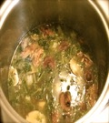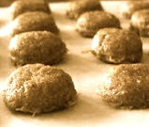

**Chicken Soup Tinctures Slippery Elm Lozenges**

Ross and Margaret worked all day in Margaret’s kitchen making these three-part cures. When they were finished they bundled them up in baskets to take to each sick person’s house. Unfortunately, right as they started to make deliveries with the wheelbarrow, it started to snow very hard and they both were worried everything would be ruined when they got it to the houses if they didn’t act fast.

Margaret’s father, who had been watching their progress with interest, offered to take them in his horse and buggy, and with his help all of the 74 healing packages were delivered in no time at all. Ross even made it home in time for dinner.

The delivery happened on a Friday night, and so they knew it wouldn’t be until Monday that they would find out if their efforts paid off. It was a good thing, too, because working so hard to put the whole thing together, and bringing them around to every sick person’s house had been exhausting, and Ross and Margaret both slept most of Saturday and Sunday away. While they slept the winter kept working its magic, and before they went back to school on Monday every branch of every tree was covered in white.

As they walked to school on Monday morning, Ross and Margaret inched along more slowly and quietly than ever before. The extra blanket of snow seemed to muffle everything and it was hard to tell if anyone was stirring about anywhere.

Margaret actually kept her fingers crossed as they approached the back of the school, hoping that she would see someone feeling better. Oh, would their cures have worked their magic over the weekend?

When they turned the corner of the school received an astonishing surprise. Not only were all the students and teachers back at school, but also every single one of them was on the lookout for Ross and Margaret and let out a big, wild round of applause when they appeared on school grounds. Shouts of, “We’re Well! We’re Well! You Did It” echoed off the school walls. Margaret was so excited to see them she jumped up and down. Ross laughed, and there were hugs all around.

That day in Mrs. Fiske’s class the students were supposed to offer a speech on a topic of their choice. Since Ross and Margaret had been the only students in school for the last few weeks they offered their talks first.

Margaret gave her talk on how to make a magical healing Chicken Soup, and Ross gave a talk on the importance of washing your hands and covering your face when you cough or sneeze to keep from spreading wintertime germs. When they were done the students couldn’t help but giving them another hearty round of applause.

It wasn’t long before Margaret was tired of all the attention. She was thrilled to see everyone feeling so much better, but as she saw it what she and Ross had done was only what a person should do. But as often happens things only got worse before they got better.

The next day, waiting for Ross and Margaret at the teacher’s desk, was a very tall reporter from the Plattsburg Sentinel, which was the local newspaper. The reporter asked Mrs. Fiske for permission to interview all the students in Ross and Margaret’s class. Slowly starting fom the back of the room the reporter worked his way interviewing all of the students in Mrs. Fiske’s class.

Ross couldn’t understand what was newsworthy about the obvious questions the reporter asked him. “Did he know that the soup and slippery elm and Echinacea tincture would heal everybody” (Of course they did). “Did they want to get back to school” (Of course they did). Ross couldn’t imagine how good old home remedies could be interesting to anyone

. 

**The Plattsburgh Sentinel**

The week Ross and Margaret’s picture appeared in the Plattsburg Sentinel with the caption “Young Healers Cure Influenza,” everyone in town wanted to meet them. When they would emerge from the woods in the morning to go to school, a crowd would be gathered outside the door of the school; when they would be on the playground grown-ups would approach them with their health concerns.

Most of the other students were equally awestruck and Ross and Margaret, while glad to have their friends back at school, found themselves spending most of their time alone.

“I don’t understand why they are making such a big deal of this,” Margaret confessed to Ross one afternoon. “We only did what anyone would have done.”

“I know,” Ross admitted, “but it sure is a good thing they didn’t know what we did with the water tower, or Freddy, or they might not like us so much.”

Margaret knew he was right, so they agreed to keep a low profile until the news died down. Ross and Margaret were both happy it was winter and nobody would want to follow them into the woods, and the Super Secret Nature Healing Society could get some peace and quiet.

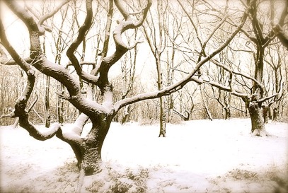

**Peace and Quiet**

Chapter Nine

A Very Wet Problem

It wasn’t long before spring was upon their small Adirondack town, and people were so busy trying to stay dry they nearly forgot about the “Young Healers.” Ross and Margaret were thrilled to be able to socialize with their classmates again. As the weather turned warmer Ross even started playing stickball with some of the boys at recess, and Margaret would jump rope and play hop scotch with some of the girls.

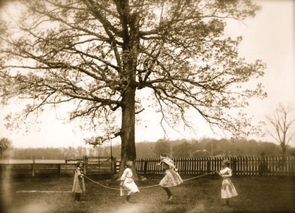

**Girls Playing Jump Rope at Recess**

It was at recess that Margaret discovered that one of the girls had a really wet problem. Susan Jacobs had always stayed to herself but a spring approached though Margaret could tell that Susan wanted to join the others but was afraid. It didn’t take long before Margaret found out why.

The way it happened was that Margaret kept inviting Susan to participate in things, and Susan kept refusing. After she had refused 5 or 6 times, Susan took Margaret aside and explained why. You see, lots of children wet their beds and pants when they are in diapers and some just after they are potty trained, but at 9 years old, Susan still couldn’t sleep a night without wetting her bed. As if that weren’t bad enough, Susan’s parents wouldn’t let her bathe in the morning before going to school. Her mother said it was too much trouble and believed that if Susan was embarrassed by her smell she might just stop wetting the bed.

Susan was embarrassed, all right. When she arrived at school each day she felt dirty and foolish and didn’t know what to do. Every morning in the school bathroom she would try to wash up enough to feel clean. Unfortunately, no matter how much she washed, all she could smell was pee. Fear of being found out was the reason she would not play, but Margaret had been so nice by asking her over and over that she had decided she might as well tell her. And besides, hadn’t that Plattsburgh Newspaper called Margaret and Ross “Young Healers”? Maybe Margaret could help her.

Margaret listened as Susan blurted out all her troubles, and realized that maybe there was something she could do. The first thing she did was go into the bathroom with Susan to help her clean up. “Our school bathroom is way too small to really clean up in,” Margaret responded sympathetically.



**School Bathroom Sign**

“You’re telling me,” Susan said with relief. So they went in the bathroom together. Margaret washed Susan’s hair with some lavender soap Meemaw had given her and that made all the difference. It turned out that when Susan cleaned up in the bathroom at school everyday her hair was the only thing she couldn’t manage by herself, and so her hair often carried that urine smell around with her all day. Margaret offered to help her wash her hair everyday before school and Susan agreed with excitement.

Even though Margaret knew she could trust Ross, she decided that it would be easier to keep Susan’s secret to herself if she didn’t tell him anything. The way Margaret figured it, once she started talking to Ross about the particulars of the cure it might be difficult to keep Susan’s name private. So she told Ross she had some private business afterschool. Then she took the allowance her father had given her, went to the junk store in town, and bought a second hand alarm clock. The clock was to help Susan wake up in the middle of the night and go to the bathroom. Margaret figured waking up once in the night would be the first step for Susan to stay dry.



**Second Hand Alarm Clock**

Once home, Margaret looked through her herb books. The best solution she could find was to grate some red onion and mix it with honey and water and have Susan drink it twice a day. This promised to strengthen her urinary tract and help her get through the night without wetting the bed. But where would she find red onion in the springtime? For this she knew she needed Ross.

That next day, for the first time, Margaret got up early and snuck into Ross’s back yard and made the secret club call. “Coocoocachoo,” she trilled over his backyard fence. Margaret was surprised at how fast Ross made it to her.

“For some reason I thought you would be coming over this morning,” he said.

Margaret was startled. How could he have known that? Margaret looked at Ross with a puzzled stare.

He laughed. “Well, yesterday you went off and did your own thing after school without even telling me where you were going. I guess I was just hoping that you would be by to let me know what was going on,” he said.

Margaret understood with relief that he wasn’t really reading her mind. She explained, “Well, a friend at school came to me with a problem, and I needed to help her. “You understand?” Ross nodded, and Margaret went on. “I did some research last night, and I realized that I need some help. The cure this person needs is in red onions, but its too early for garden onions. I thought maybe you would know a place where I could find some wild red onions.”

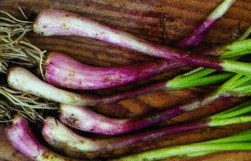

**Wild Red Onion**

Ross smiled and said, “Of course, let me just get my jacket.” With that he ran inside, put on his jacket, said goodbye to his mom, and headed out to help Margaret.

That morning before school Ross showed Margaret six places where wild onions grew in bulk. Over half of them were red onions. The smell of the wild red onion was stronger and more pungent than any other red onion Margaret had ever smelled. She was so thrilled that she gave Ross a hug. While they were digging onions, Margaret mentioned that the potion she was making also needed honey, and Ross, while offering to ask Meemaw for some honey, grew rather curious about a recipe that needed onions AND honey. “You know you can trust me to keep a secret, don’t you Margaret?” Ross asked tentatively.

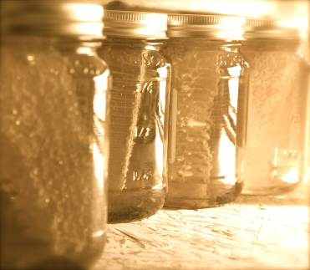

**Meemaw’s Honey**

“Oh yes, I do. We took an oath,” she said, and, knowing what he was getting at, she added, “It’s just that I don’t want to give away my friend’s secret.”

“I understand that,” Ross said, “but couldn’t you just tell me what the potion is for, without telling me who it is for?” He added the promise, “Even if I found out who it was for, I promise I wouldn’t tell a soul.”

Margaret considered this carefully and then decided that Ross was in the Super Secret Nature Healing Society with her and she ought to have a bit more trust in him, so she explained that the cure she was making would help to firm up a person’s bladder and make their urine track more healthy so they wouldn’t wet the bed.

Ross tried not to laugh at her seriousness and then realized he knew about six of the boys in their class who might need the same cure. Not only that but his own brother Jonah who had just turned 11, also, still wet his bed and had to endure all the older brother’s teasing to boot. “I know quite a few people who might benefit from that same solution.” Ross offered tentatively.

“I wonder how we could get this to them without embarrassing them,” Margaret replied.

They decided not to talk to anyone about it but instead to leave the cures, with just people’s names and instructions where people would find them and hope that those in need might give it a try. Margaret, of course, gave Susan her cure face-to-face. It wasn’t long before Margaret and Ross received equally secretive thank you notes from a whole lot of much dryer people.

Chapter 10

Shoo Fly Don’t Bother Me

With spring so fast upon them, many of the homes in the Adirondack woods, as well as the schools and businesses, were wrestling with infestations of some sort or another.

Mice were a particular pain in the neck in the springtime. When the earth was so muddy from snowmelt and food at the small rodent level was scarce. The mice would explore inside spaces in search of a banquet.

Flies were another problem altogether. When flies got in your house it was hard to tell what got them there. Flies usually feed on rotting stuff, and if you didn’t have a pile of rotting stuff somewhere (which most people didn’t) it was hard to tell what attracted them.

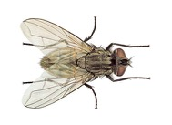

**Housefly (Not the Actual Size)**

The most difficult thing about houseflies is that while they live only about two weeks to a month, in that time the female housefly can lay about 500 eggs. This means the flies can keep coming and coming and coming.

What brought Ross and Margaret into this problem was that Plattsburg Sentinel had written a story about how many germs houseflies carry and this had gotten everyone in an uproar. And since Ross and Margaret were now well known for keeping people healthy and getting rid of germs almost every person in town came to them to ask how to get rid of the flies.

The other reason it became Ross and Margaret’s problem is that their classroom had a particularly bad case of flies. Mrs. Fiske said she thought someone had eaten something at the window and the crumbs had attracted the flies. Ross and Margaret knew this couldn’t be true: the paper had said that flies mostly eat feces (which is poop) and open cuts and spit. It was hard to imagine that anyone would have rubbed enough of that stuff on the window to attract the thousands of flies that were there.

With a little investigation Ross realized that the school groundskeeper had spread cow manure on the flowerbeds just outside the window, and he thought that was most likely attracting the flies. This caused an even bigger concern. though. It would be impossible to move all that manure, and so what could they do?

This is where Margaret’s big brain came in handy. She had read in some book that flies have compound eyes, which means their eyes are made up of thousands of little points that take in light instead of one, as people have. Because of this, in some places they had been able to get rid of flies simply by creating an optical illusion, to scare them off.

Ross and Margaret brainstormed things that might seem scary to the flies and settled on a jar with a bit of water and three shiny pennies in it. Mrs. Fiske let them put it in the window at the end of the day, and everyone crossed their fingers that it would work. (That is everyone but Mrs. Fiske who thought that it was a crazy idea).

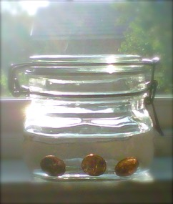

**The Penny Solution for Flies**

And you know what? The next day when they came into school the flies were GONE! Mrs. Fiske was astounded! Ross and Margaret had done it again!

It was surprising how fast the fly solution spread. Before you knew it there was hardly a house in that Adirondack town that didn’t have a jar with water and pennies in it. Visitors to the woods would see these in the windows and wonder what they were. Some guessed that the pennies were for luck and others that the people were trying to grow their own money. Not one person who ever saw the pennies suspected that they were to keep away the flies. That was mainly because once everybody had those jars in their windows not one person ever saw flies inside the house again.

Mice on the other hand were a whole other problem that couldn’t be remedied quite as easily. Some people used mousetraps, and others were careful about protecting their food supplies. Ross and Margaret noticed that Meemaw didn’t do either of these things, but she was able to keep the mice away, and it wasn’t long before they found out how.

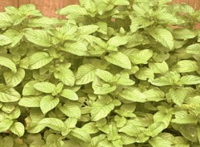

**Meemaw’s Mint Plants**

It seems that long ago Meemaw’s great grandmother had planted a batches of peppermint around the foundation of the house. And peppermint it seems is a natural deterrent for mice. Ross and Margaret let everyone know this trick and pretty soon most of the mice preferred to stay in barns and outside than to try to enter the mint filled houses. And Adirondack visitors who had no idea what the mint was doing got the idea that mint grew quite naturally around foundations of houses in those parts.

Chapter Eleven

The Pathless Wood isn’t Really Pathless

There were countless times when Ross and Margaret were surprised by the things Meemaw knew without knowing. Such as the time she knew who Margaret was and that she would be there for breakfast without Ross telling her, or the way she always knew that they were done with the chores and it was time to bring the breakfast out.

When Ross asked his mother about Meemaw’s knowing she explained by saying, “She just knows stuff.” But Margaret and Ross thought it was something more. With no doctor’s training, how did she always find the proper cure for whatever ailment someone brought to her, or the right thing to say to heal a hurting heart?

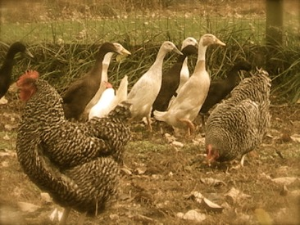

**Meemaw’s Chickens and Ducks**

She seemed to have a way with animals, too. The ducks and chickens in her farmyard always lay more eggs when she was having company, and the sheep would come to her as soon as she would call their names. The old robin who hung around the garden seemed to talk to Meemaw as she worked, and Meemaw would always talk back. And while the Robin would go away in the winter, it always returned to her in the spring.

Even her plants seemed to respond to her in ways they didn’t to anyone else. A nearly dry almost dead flower or herb seemed to perk up at the sight of her, and all of the seedlings she planted grew more quickly than the ones Ross and Margaret planted even if they came from the same group of seedlings and were planted in the same soil. And no matter what mushroom or herb she needed to find in the woods, she always seemed to know right where to find it, and sometimes they would even spring up randomly in her garden.

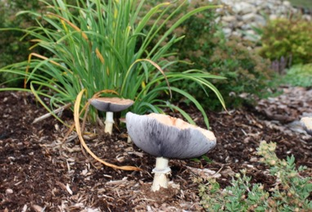

**Unplanted Mushrooms in the Garden**

Margaret and Ross knew that Meemaw planted her seeds and her seedlings on the full moon, but they weren’t sure why. They had also seen her ask questions to three coins that she threw three times, but they never understood how she got the answers.

One time when they were out looking for special roots, Meemaw took out a short chain with a heavy stone attached and watched as it went around in circles to decide where to go to find what they were looking for. In short, Meemaw never seemed lost no matter how lost she really was.

One Saturday morning over blueberry pancakes, Ross and Margaret finally got up the nerve to ask. “Meemaw, how do you seem to know everything?” Ross blurted out while Margaret nodded her head.



**Blueberry Pancakes**

Meemaw smiled and coyly answered with, “What do you mean Ross? Do you think I am a know it all?” Ross and Margaret were taken aback and both stammered, “No, no, no, no!”

Margaret tried to frame the question again. “Meemaw it’s just that we always wonder how you know stuff before anyone else does, like when the weather is going to change.”

And Ross chimed in, “Yes, and how you know what we want to eat for lunch before we tell you or how you know what salves my mom needs before she asks.”

Meemaw sighed and smiled at them. “It is interesting to me that you two are the only ones who have ever asked me about that,” she said.

Meemaw motioned for them to come into her living room, and she opened a drawer. In it they saw the coins she had used and the chain with the stone she had used and some rocks with unusual symbols on them.

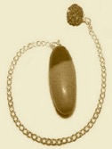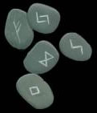

**Pendulum Runes I-Ching Coins**

She told them that these things were her divination tools and that they helped her to answer questions when she didn’t know what the answers were. She told them that the chain with the rock on the end was called a pendulum and taught them how to use it to answer yes and no questions.

Meemaw also told them of how she paid attention to her dreams and how sometimes her dreams told her things were going to happen before they did.

Then Meemaw explained that more important than any of these tools, and perhaps even more important than their dreams, was their intuition.

Neither Ross nor Margaret had ever heard of intuition before, so Meemaw explained that intuition is the ability to know something without the need for facts or to think it through. Meemaw asked Margaret how she had ‘known’ to make an Echinacea tincture when the whole school had the flu.

Margaret remembered just sort of knowing what Echinacea was good for and simply feeling certain that the Echinacea tincture would help. She wasn’t sure how she knew, but she knew.

Then Meemaw asked Ross how he had known that Margaret was his friend. Ross considered this in the same way Margaret had. He felt as though he had known Margaret was his friend the second she took an interest in that wildcat print but he realized there wasn’t any real reason he knew that she was going to be his friend: he just knew.

Meemaw went on to explain that ‘just knowing’ was, in fact, intuition. She explained that to be a real healer the most important thing to do is to learn to trust that sneaking feeling you get. Then she said, “When you lose track of where you are, you can almost always find the way if you trust your intuition. It will tell you where to go.”

Ross and Margaret weren’t sure they completely understood, but they rolled these ideas around in their heads. Learning to trust their intuition seemed a very important part of club business.

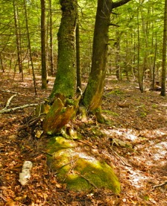

**Where Ross and Margaret Sit to Talk**

On the way to school the next Monday, Ross and Margaret discussed ways to learn to trust their intuition. Ross suggested playing some games of hide and seek, to see if they could get better and better at finding each other with no clues. Margaret thought that was a good idea, and they played a while before school.

After school, Margaret suggested that they each take turns writing a word on a piece of paper to see if the other one could guess it in three or fewer tries. This was much harder, but eventually they got very good at guessing what each other would write.

And finally they both decided to keep a journal. A journal is similar to a diary where a person writes down thoughts and ideas to refer to later. Margaret had suggested this because she thought that if they wrote down each day the thoughts that came to them they could see if they could trust their intuition more and more over time. Ross suggested that they also write down their dreams so that they might be able make some connections between the things that were happening and what they were dreaming about.

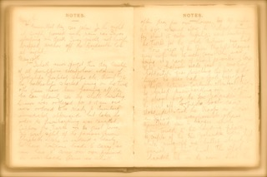

**Ross’ Journal**

That very first night Ross had a dream that he was stranded on the top of a foggy mountain and unable to get off but that Margaret had found a tunnel and, quick as a wink, they were safely home.

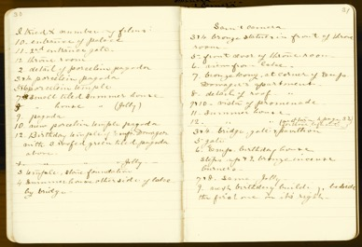

**Margaret’s Journal**

Margaret also had a dream that Ross had a very mysterious illness that had left purple bumps on his tongue and that she suggested he eat tons of spinach and molasses cookies to get well.

They both thought these dreams were silly, but they wrote them down all the same.

Margaret also had a few moments of what she thought might be intuition. For example, one day she woke up thinking about Eleanor (one of their classmates at school) and sticking the salve for poison ivy in her bag that day for no reason, only to have Eleanor approach her at the beginning of the school day to borrow a pencil with a bit of poison ivy on her hand. Because she had trusted her intuition she had been able to help Eleanor out right away.

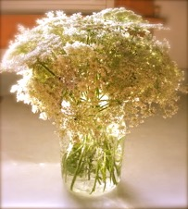

**Queen Anne’s Lace for Mrs. Fiske**

Ross too had trusted his intuition that day. He had felt a twinge in his heart to do something nice for Mrs. Fiske and brought her a bouquet of flowers only to find out that Mrs. Fiske’s mother, who was getting on in years, had kept her up all night with a cough and so Mrs. Fiske hadn’t come into school in a very cheery mood at all—that is, until she saw that Ross had brought her a bouquet of her favorite flowers: Queen Anne’s Lace.

Ross and Margaret wrote these occurrences down and pretty soon their diaries were getting rather full. One Saturday both Ross and Margaret brought their books to Meemaw to show her what they had been doing.

She smiled and encouraged them. That day she brought out the strange rocks. She told them that divination tools are not really to tell the future, but rather they help you to pay attention to the things that are already happening all around you. She taught them the names of the rocks and what each of them meant.

After lunch Meemaw took them to a special bench in her garden that sat amid the old lilac trees and explained that it was where she went to sit and just listen and pray. “Some people might say that the divination tools I showed you are bad and wrong, but I believe that they are just another way of praying to the creator, the one some call ‘God’. Opening up and listening is as important as talking and praying, and this is where I like to sit and listen to what nature has to share with me.”

Ross and Margaret understood listening to nature. They had always listened the birds and to the winds and to what the sway of the trees had to say. Margaret remembered how she felt her tamarack tree speaking to her and Ross thought of how he felt each time he discovered the track of an animal. There are countless ways that nature speaks to people. All you have to do is listen.

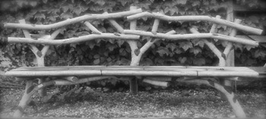

**Meemaw’s Special Bench**

Meemaw suggested that Ross and Margaret find some time each day to just sit and listen. They shared with her their notebooks, and the things they were noticing impressed her, and she said she was glad they were writing down their dreams.

Ross and Margaret were still confused by their first dream. Ross could think of no mountain that had a tunnel to the bottom, and Margaret had no idea what molasses cookies and spinach would cure. No sooner had they given up trying to figure it out than Ross started feeling so tired he stopped coming early to play with Margaret in the woods. He would apologize but he felt so tired he would even head home right after school to get in bed for a nap.

This confounded Margaret. What was making Ross so tired? She tried to talk to Ross about it, but, to be honest he was too tired to even care.

Then, one afternoon after Ross had been sleeping for about two weeks, Margaret discovered a leaf that had purple spots on its under side and remembered the dream she had. She went right home and picked all the spinach in her garden and made a large batch of molasses cookies. She went to Ross’ house and encouraged him to eat them.

Ross felt so foggy and tired he didn’t feel much like eating, but he, too, remembered his dream where he was on top of a foggy mountain and Margaret showed him the tunnel to get out fast, so he ate the spinach and molasses cookies.

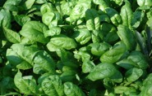

**Molasses Cookies Spinach**

After about four days of eating spinach and molasses cookies Ross felt 100 percent better. And the first thing Ross and Margaret did was run to tell Meemaw what had happened.

Ross told her about how light headed and foggy he had felt, “as if I were at the top of a mountain,” he explained.

Margaret told Meemaw about how worried she had been about Ross and how the leaf with the purple spots reminded her of her dream even though she still didn’t have any idea what spinach and molasses might cure.

Meemaw explained that molasses and spinach both contain iron, a mineral you need to keep your blood healthy. She explained that there were lots of foods such as lima and kidney beans, and collard greens and salmon and even nuts and egg yolks that help to keep our blood rich with iron. Ross hadn’t been eating many green vegetables or lean meat and so he was probably tired because his blood was weak in iron. Margaret’s dream had shown the way. Meemaw was very proud of them for paying attention.

Chapter Twelve

The Cycle of Life is Sometimes Sad

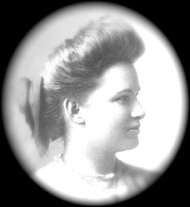

**An 1856 Photograph of Mary Higginbotham (Meemaw)**

Nobody was quite sure how many years Meemaw had been around, but it was common knowledge that she was over 90 years old. She had lived by herself since her husband (Ross’s grandfather) had died over thirty years before, so Ross and Margaret’s visits every weekend were a great blessing to her. She appreciated their help, she loved to hear their stories about school, and she was always amazed at their problem solving abilities. She had lent Margaret loads of books and had over the months, taught Ross and Margaret to cook and to bake all kinds of family recipes.

Meemaw had taught Margaret and Ross how to make Popovers, Scones, Buckwheat Pancakes, Chicken Soup, Gingerbread, Annadama Bread, Buttermilk Pie, Rhubarb Pie, Pound Cake, Baked Beans and Taffy. (You will find all these recipes at the end of this book). There had been eleven cooking lessons in total and in that time they had become more than students and teacher or grandchild and grandmother, but also the very best of friends.

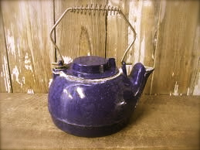

**Meemaw’s Tea Kettle**

Despite her 90 or more years on earth, Meemaw had always seemed spry and healthy to Ross and Margaret. And so it was a very sad Saturday when they went to see Meemaw and found that she hadn’t even gotten out of bed. She told them that she was tired. She explained that it was quite common for old people to feel tired, and she asked Ross if he would mind putting the kettle on for tea.

Margaret realized that Meemaw hadn’t eaten anything for breakfast, so she suggested that maybe if she made some popovers (Meemaw’s favorite) she might eat a bite. Meemaw agreed, and Margaret started to work. While Margaret was waiting for the popovers to bake, she cut up some strawberries she found in the kitchen garden and added a bit of vanilla sugar that Meemaw kept in the pantry. Vanilla sugar is sugar that has sat a while in a jar with vanilla beans. Meemaw had taught Margaret that when you sprinkle a bit of vanilla sugar on something it makes it taste special. By the time the popovers were finished the whole house smelled delicious.

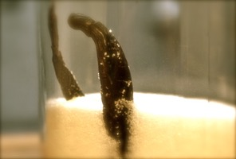

**Vanilla Sugar**

By the time Margaret got back to the bedroom with the tray of food, she saw that Meemaw had fallen asleep. Ross motioned for her to return to the kitchen, and that is where they sat and had their tea and breakfast. Margaret half-baked another batch of popovers to stick back in the oven as soon as Meemaw awoke. When she finally was able to bring them in, they were smothered in butter and honey and there were delicious strawberries on the side. Meemaw smiled and seemed happy for the tea and breakfast, but she could only eat 4 bites and drink 7 sips of tea. As soon as she was finished with her small meal, she went back to sleep.

Margaret and Ross were worried, and so it wasn’t long before they started brainstorming what could be done to increase Meemaw’s appetite. Meemaw overheard some of their planning, and she gathered them near her and told them not to worry about her because there was nothing to be done.

Margaret and Ross had their minds so trained for curing people that this came as a surprise. “What do you mean?” they almost said in chorus.



**Everything Has A Season**

And that is when Meemaw told them the thing that rang so true in their hearts that they could never forget it. She said: “You two are very precious to me, and nothing hurts my heart more than to think of leaving you. At the same time, there comes a moment when every spirit must leave this earth, and I know my time is drawing near. If I know one thing it is that life is the most precious gift of all, and the most important thing to do is to live it until it is through. I was able to live my life more fully because of the two of you.” Meemaw said this with a tear in her eye, and she paused for a minute and reached out and gave a hug to both Ross and Margaret. Then she went on. “Life ends at different times for every body. Some people’s bodies give out when they are young, as your mother’s did, Margaret. Some people’s bodies last until they are as old as mine. Whether the ending time comes fast or slow or a life is short or long, death always comes too fast and too soon and with great sadness. The cycle of life is sometimes very sad. Yet we see the cycle of life in every changing season and in every flower and tree, and we know that the cycle of live is also unbelievably beautiful.

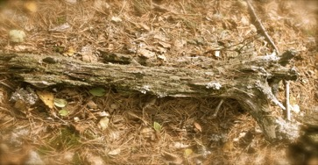

**Even Trees Become Fertilizer For Other Trees**

Meemaw noticed Ross and Margaret tearing up, so she paused and then added, “It’s natural to be sad. It is sad to separate from the ones you love. I am, sad, too and at the same time I am grateful-grateful that I lived long enough to see what amazing healers you are becoming and what wonderful grown ups you are going to be. I am grateful that I was able to touch so many lives with my own life. And you know what else?” She said with enthusiasm.

With their eyes tearing up Margaret and Ross couldn’t imagine what could have brought on Meemaw’s sudden smile, and so they shook their heads “no” and she continued. “I am also excited, because I know there is some life after this. Everything that dies is a seed that is planted or a fertilizer that helps other things grow and I know that I, too, will be on to that next part of the cycle of life, and I honestly can’t wait to find out what it is!”

This surprised them both, and they weren’t quite sure what to make of it, and so they held it in their heart to ponder over. It was sunset, so they got Meemaw comfortable, kissed her goodnight, promised to come back on Sunday as usual, and then they headed home. It was a sad walk home.

When Ross got home, he explained to his Mother what had happened that day. She only said, “She’s a tough old bird,” and didn’t seem concerned, but at Ross’ urging she agreed to go with them the next morning to see if Meemaw needed anything she could offer.

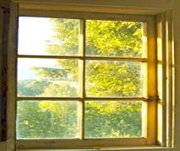

**Meemaw’s Bedroom Window**

When the three of them approached the house Sunday morning, it seemed unusually beautiful. The birds were singing up a storm and the sunshine was bright. At the same time there was a curious stillness.

Ross’s Mother entered the house first, with Ross and Margaret following close behind. When they arrived in Meemaw’s bedroom, they were all struck at how peaceful she looked and realized at once that her spirit had left her body while she was sleeping.

Ross’s mother set about making funeral plans. She sent Ross to tell his brothers Joseph and Edward to go get her sisters and have everyone come to Meemaw’s house. Margaret set about to cleaning Meemaw’s house and making a few foods for people to eat when they arrived, and Ross’ mom prepared her body by washing it and putting on fresh clothes.

It wasn’t long before the house was full with Ross’ uncles and aunts and cousins. They all came to say goodbye to Meemaw. Some of them cried and others didn’t. Everyone seemed to have different feelings and to say goodbye in their own unique way. Ross’ mother had found on Meemaw’s night table a pile of papers explaining her wishes, and plans were made for the burial the next day.

Through the night, Ross’ uncles and his brothers built a pine box for Meemaw’s body, and when it was finished his mother and aunt placed her body in it.

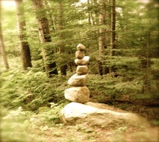

**The Rock Cairn Marking Meemaw’s Grave**

The next morning the whole family and even Margaret and her father gathered at the edge of the field where the wildflowers grew to say goodbye to Meemaw. The minister came and said some words, and so did almost everyone in the small crowd. When they were finished, they filled in the hole where they had put the pine box with Meemaw’s body, and then everyone placed a stone on the spot, to mark her grave. This created a rock cairn, which is sometimes used to mark a grave, and is sometimes used for markers on a path in the woods.

Since Margaret, Ross and some of the other cousins had made piles of good things to eat, when they returned to the house they lingered for a long time, eating and talking about Meemaw and how she had made their lives so much better.

**Some of The Wonderful Luncheon Food**

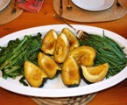

**Squash & Beans-Roasted Potatoes-Chicken Salad**

During lunch Margaret overheard loads of stories about how Meemaw had cured not only obvious symptoms but also hidden ones, and how she had listened to people and held their hand when they most needed a friend.

When they were done eating and talking Ross’ Mother and her sisters asked the family to gather round. Margaret and her father took this as a cue that they should leave and so they started toward the door with the other friends, but Ross’s mother said, “Hiram and Margaret (Hiram was Margaret’s father’s name), I hope you will stay for this.” And so they did.

Ross’ mother started to explain. “We all know that Meemaw was a complex woman and that she had many friends besides us family.” Everyone nodded, and she got right to the point. “It seems she had two people that she relied on very much, and she has left them this homestead.”

There were lots of questions about this “How did you find that out?” Meemaw’s oldest daughter asked.

“Next to Meemaw’s bed, along with her funeral arrangements, I found this will.” and Ross’ mother held up a piece of paper that looked pretty official.

“How much property does she own?” the younger of Meemaw’s daughters asked.

“It seems she owned this house and everything in it as well as the 81 acres it sits on this side of the creek and another 30 acres on the other side.” Then Ross’ mother continued, “It seems she wanted things to stay pretty much the way they have always been.” You could tell this made sense to everyone, because there were a large number of nodding heads. “And so she left all her worldly goods to Ross and Margaret.”

Nobody made a sound except Margaret who started crying hysterically and couldn’t stop. Ross’ mother leaned down and picked Margaret up and rocked her back and forth. “Sweet Pea, you and Ross were so precious to my mother, you meant the whole wide world to her. I hope you know that deep in your toes.” This calmed Margaret down a bit and she nodded through her tears.

Everyone else started chattering at once—that is everyone except Ross and Margaret and Hiram, who stayed absolutely still. If the house was going to stay nice until Ross and Margaret were grown-ups, somebody would have to live in it right now, and so it was decided that Margaret and her father Hiram should move in right away.

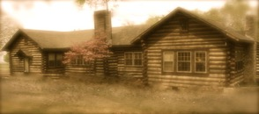

**Meemaw’s House**

Now Hiram, who had been listening very quietly to this whole conversation, was very surprised by its twists and turns. He had also never seen his daughter cry, and he wasn’t quite sure what to do about that. When they said he and Margaret should live in the house, he was frozen solid. You see, he and Margaret had lived in a very small house on a very small piece of land for a very long time. He didn’t mind the smallness at all, because it was the house that he and his wife had built together. Even though it was small and imperfect, the house reminded him of Margaret’s mother and all their times together, and it was hard to imagine leaving it, even if Meemaw’s house was bigger and her property better in every way.

Ross’ mother noticed Margaret’s father having trouble speaking up and she said in her calm almost musical voice, “Would that be ok with you Hiram?” and the room went quiet.

Hiram cleared his voice and said rather coldly, “I don’t want to impose on you people. I am sure she didn’t mean us to take this homestead out of the family’s hands, and we are perfectly comfortable where we are.”

Margaret was so surprised that her father was acting this way when Ross’ family was being so generous that she stopped crying immediately and almost shouted, “I don’t understand what you are saying, Father!”



**View from Meemaw’s Porch**

If it was possible, the room got even quieter. And then Ross’ mother put Margaret back down onto the sofa next to Ross and walked over to Hiram. Taking his hands in hers, she said in her soothing voice, “Hiram, I know you miss your wife and it might feel like she is in your house, and that might seem like a good enough reason to stay there. But you would not impose on us to stay here, you are doing us a great favor. We want you and Margaret here because Margaret was Meemaw’s student and her friend, and in the same way that you still feel Maggie’s presence (Maggie was Margaret’s mother’s name) in your house, Margaret will be able to complete Meemaw’s life plans if she lives here.” At these words, Hiram, started to cry. He knew she was right, and he knew he and Margaret would move into Meemaw’s house.

Everyone agreed to help them move, and Ross’ cousin Keith, who had recently been married, agreed to move into Hiram and Maggie’s house to keep it nice until Margaret and Ross were old enough to take care of Meemaw’s property by themselves and Hiram could move back in. Before much time at all had passed, Margaret and her father were living in Meemaw’s house and Ross’ cousin was living in Hiram and Maggie’s old house and it felt as if everyone was exactly where they were supposed to be all along.

Ross’s routine didn’t change much at all after Meemaw died. He still came every Saturday and Sunday to weed her gardens. With all of Meemaw’s cookbooks, Margaret’s cooking kept getting better and better and so there wasn’t much difference between the tastes she offered and the ones Meemaw had offered. The only real difference was that Margaret would make his breakfast instead of Meemaw, and Ross and Margaret would decide together how to spend the day.

Still, they both missed Meemaw. She had been the bright spot in their week, the person they most wanted to talk to when they had a problem and the one they wanted to share their every happiness with. Ross and Margaret spent a great deal of time pondering Meemaw’s words on the day before she died. They knew what she meant when she said, “Everything that dies is a seed that is planted or a fertilizer that helps other things grow,” and this encouraged them to keep looking and looking for signs of the rebirth of Meemaw all around them.

The first sign came when the Robin that Meemaw had always talked to in the garden appeared again just after Margaret moved into the house. It would sit in the tree over the garden talking to Ross and Margaret as loud as ever, as they worked.

The second obvious sign was that the bee balm they had planted for Meemaw last summer, which had been a small straggly patch of nothing the summer before, had become a hearty field of bee balm in the summer after her death. Everywhere they looked, Margaret and Ross saw evidence that Meemaw’s spirit was still with them on that property, and, by looking and remembering, they felt her nearby.



**Meemaw’s Bee Balm Before and After**

Chapter Thirteen

The Secret Place Everybody Knows About

One Saturday, Ross and Margaret decided to explore the property on the other side of the creek. Meemaw’s beehives and pine trees were primarily on the side of the creek where the house was, so they had never had much cause to get over to the other side.



**The Creek**

There was a path up to the creek and a bridge to get over, but there didn’t seem to be much of a path on the other side. Heading out this way, without a real plan about where they were going, made Ross and Margaret feel like they were out on a gigantic adventure.

They decided to head to the top of the hill and see what was there. As they climbed, they hit upon an overgrown path where there were stairs, which they were grateful for since the climb was steep. When they got to the top of the stairs they came into a meadow and found the most surprising thing of all; a little round stone house. They were so surprised to find it that they weren’t even sure it was on Meemaw’s property, so they looked around for a property marker like the ones marking Meemaw’s property on the other side of the creek. It wasn’t long before they found one just down the hill on the other side from of the house, and they were relieved to realize the house did in fact belong to Meemaw.

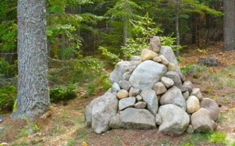

**Property Marker**

On the front of the round house there were 5 locks and they were all locked. Locks were strange things to find in the Adirondack woods where nobody usually locked their house even when they went away for long periods of time. Having found the locks they knew they had to find the keys and so they looked under every rock on the mountain.

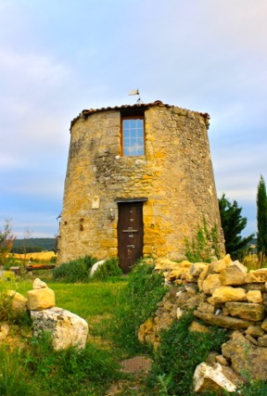

**The Round House**

As you might imagine, they found nothing at all. The sun was starting to set, and Margaret and Ross had to get home so the round house was going to have to stay a mystery at least one more day. The next day was Sunday and they agreed they would spend it looking for the keys and, they hoped, unlocking those locks.

That night Margaret turned Meemaw’s house upside down. She did it while she was cleaning so her father didn’t suspect a thing. She looked through every drawer and behind every book for keys. She found nothing. Finally, exhausted, Margaret fell asleep.

The next morning Margaret made pancakes, put them in the oven to stay warm, and went out early to help Ross weed. “I looked through the house, and I didn’t find a thing,” she told him, even before she had said, “good morning.”

“I didn’t really think you would. I tried to ask my mother about some keys, without telling her about the house, and she seemed as surprised as we were to find any locks.” This puzzled Margaret as Ross said it. How could Meemaw have hidden a locked house from her daughters? The round house was becoming a bigger mystery every second.

While they were weeding the garden, Meemaw’s robin kept hopping up and down on the bench and singing “*Cheerily, cheeriup, cheerio, cheeriup.”*  The robin became so loud and so insistent that Ross snapped, “Be quiet bird!” When they were done weeding and Ross was dragging the cloth with the weeds over to the compost pile, Margaret went to see what in the world robin was trying to tell them.

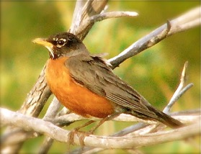

**Meemaw’s Robin**

“Hey, look at this” Margaret called to Ross as he walked back into the garden. Robin had been hopping and pecking and *cherriuping* over a ribbon that was tied to the bench in the garden, and when Margaret and Ross inspected they found a water stained muslin bag with 6 keys tied to the bench with a ribbon.

They were both so excited, and without thinking, Margaret kept saying over and over, “Oh thank you Robin! Thank you, Robin! Thank you, Robin!” The robin had calmed down and returned to his usual roost once they opened the bench and found the keys, so there was no question that they had finally understood what he was trying to tell them.



**Set of 6 Keys Found in Bench**

Ross and Margaret were so excited that they skipped breakfast and ran straight to the round house with the keys. The only problem was that there were 5 locks and 6 keys. It took about an hour for them to get the doors unlocked, but it was worth it because when they went inside they found a place meant just for them.

To begin with, it is important to know that the house was furnished mainly with couches that were covered in sky blue fabric and that each pillow showed a carefully embroidered flower that could easily be found in Meemaw’s garden.

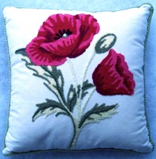

**The Poppy Pillow next to Meemaw’s Poppy’s**



**Lilly Pillow next to Meemaw’s Lilies**

There were two levels to the house, with a ladder to get from one floor to the next. There was a big fireplace, and it was clear that this house had been used in both summer and winter. There wasn’t a kitchen of any sort so it wasn’t clear how long a person might stay, but it was a comfortable place to sit and read a book or look out at the sky and to dream. The house had clearly been a respite for Meemaw at some part of her life. There were books she loved on the shelves and even stationary with her name on it at a little desk.

Ross and Margaret wondered when Meemaw might last have been there. That is, until Ross found on the desk a letter addressed to them both. It was dated just May of that same year. The letter was carefully printed on a piece of Robin’s Blue stationary. “Wow, she was just up here two months ago,” Ross said to Margaret with amazement. “Will you read this out loud?” Ross asked. And Margaret picked up the letter, settled onto the blue sofa, and read.

For Ross and Margaret May 11, 1919

My Dear Precious Ones,

If you have found this place, not only are you very good detectives but, you must also now be the owners of all this land. This spot here is my very special secret land, a spot that all of my children know about because I told them stories about it, but that they have never ever seen. Ross, your mother likely believes that this house is a figment of my imagination. She has heard about the magical windows that show the whole world, and the pillows that have captured the essence of every flower in the garden but she does not think these things are real. She thinks I made them up.

This old building used to be the silo that held the wheat for my father’s cows. Ross, when your grandfather and I got married we moved to his homestead, the log cabin across the creek, and every day I would walk over to this farm and take care of my parents. One night the barn caught on fire, and all of the animals inside the barn died. My parents tried to save them and were caught in the fire and died too. The only thing that didn’t burn was this silo. These were very sad days for me. I could not understand why this happened. Ross, your grandfather was very patient with me. He knew that I needed time to be sad and that if enough time passed, my sadness would turn to joy again.

One day not long after this happened, he brought me to this silo, which he had converted into this lovely parlor, and he told me that this was my place to be. This was, and has been since, my place to have my feelings, and I came to it whenever I wanted and stayed as long as I liked. This silo has been my quiet place, a place to sit and sew, to write and to remember and to dream, and now I give it to you.

I know you love me and I know that if you are reading this,, you are probably missing me. And I just want you to know that I love you, too. I give you this place and encourage you to use it as a quiet place to be. Remember, I am always with you in the whisper of the wind and in the sunshine and the rain, and if you sit with your sadness long enough it will always turn to joy.

Loads of love.

Your,

Meema

When Margaret had finished reading the letter she looked at Ross, and it was as if they both silently understood that Meemaw was with them and that all they would ever need to do to feel the healing of her spirit was to sit in this silo room far away from everything and just be.

While it sounds sort of simple, “just being” is, in fact, pretty hard. To ‘just be’ with your feelings you have to let them flow. When you’re happy this is a pretty easy thing to do, but when you’re sad it can be quite difficult because a body wants to make your feelings either bigger than they are or make them smaller by hiding them, and the trick is to feel everything exactly as it is. When she was still alive, Meemaw had taught them that sometimes when people try to hide their feelings, even from themselves, they end up becoming sick in other ways. Hiding your feelings can give you a cold; it can make you isolate yourself from other people and feel lonely; it can keep you from sleeping at night; and it can even make it hard to eat. There is great wisdom in learning how to “just be” with your feelings, and Ross and Margaret were grateful for having the time and the space to practice.

They made a plan to spend every Sunday after chores, in the round house “just being.” More often than not, they sat in the house and did nothing but breathe, and sometimes Ross would go upstairs with a diary and try to write a story about his grandmother that he hoped to someday tell his own children. And sometimes Margaret would try her hand at needlepoint and making a pillow to match the only flower that seemed to be missing –cosmos.

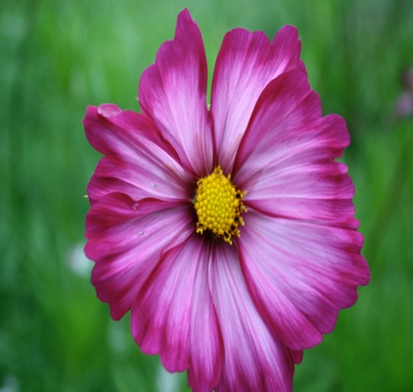

**Meemaw’s Cosmos**

One Sunday afternoon, after Margaret’s pillow was finished and Ross needed a break from his stories, they invited the whole family to Meemaw’s house for a picnic. After lunch, they led them up to the round house. They told each family member that they could use the round house anytime they wanted. Ross’ mother and aunts were surprised that the house was real, and while his brothers thought it was too fancy they liked the view. Not many of them understood the importance of “just being” but at least the house was no longer a secret, and from that moment on everyone who needed a hug from Meemaw knew where to go to get one.

Chapter Fourteen

Beauty Is More Than Skin Deep

Once everyone knew that Ross and Margaret could be found in the round house every Sunday, and that is where they would look for them. Sometimes they looked for them to bring them up some lunch; or sometimes they just came for a visit. Some came to see the magnificent silo parlor; some even came to learn how “to be.” But the main reason people came to the round house was to ask a question or to get some help with a problem. Margaret was happy that it worked out this way, because she always felt that when she helped people from the round house, Meemaw was healing them, too.

The first person that came for healing was Ross’s brother Theodore, who had a problem with warts. Warts are hard little bumps that form on the skin. Margaret knew from her reading that they were caused by a virus and often went away within a year or so. Unfortunately, though, Theo’s warts were on his nose, and he felt very self-conscious about them. You see, Theo had just turned 16, and he wanted to start dating. His warty nose made him think nobody would find him attractive, so night and day you would find him in the mirror lamenting his warts. That is, until his twin brother Andrew forced him to come one Sunday to see Ross and Margaret.

At first Ross laughed at his brother’s concern, but when Margaret took it very seriously, Ross started to as well. Warts are really no laughing matter, especially when they are out in the open where everyone can see them or in a place, such as your feet, where they sometimes hurt. Margaret figured that, since warts are a virus, anything that would kill a virus would kill the wart go away faster, so she ground up a bunch of garlic, made a plaster, affixed it to Theodore’s warts, and then covered them with a thin fabric called gauze to keep the garlic in place. She told Theo to do this every night before he went to bed and to wash it off in the morning. Ross also suggested that Theo eat, as much garlic as he could stand because having the antiviral inside his blood, he thought, would also help to destroy the virus.

Desperate to make his nose wart-free, Theo would have agreed to ANYTHING. Luckily, about one week later, the warts were small blemishes and by the second week they were gone. Theo was thrilled. His confidence grew, and he finally sent a note to a girl named Sheila and invited her to join him for a picnic by the pond.

Margaret was so happy that Theo had planned his first date that she agreed to cook for them. And so it was planned that the next Sunday the wart-less Theo and his date were to be down by the pond, enjoying Margaret’s tasty fried chicken and apple pie.

The funny thing was that Theo had sent a note to Shelia to ask her on a picnic and so she hadn’t seen Theo since the wart removal. Sheila expected that the boy who asked her on a date had three warts on his nose, so when he picked her up to take her to the pond at noon on Sunday, she almost didn’t go.

You see, Sheila was an avid reader of the weekly fashion section in the *Plattsburg Sentinel* and the *Women’s Wear Daily Magazine.* She would measure her own beauty against those pages and had determined she was downright ugly and nothing could be done about it. Thinking you are ugly is a pretty common problem when you are comparing yourself to everyone around you. It’s better to just be yourself and love yourself for who you are, but Sheila didn’t know how to do that. As a result of her comparing mind, Sheila had felt some relief when a boy with warts on his nose had asked her on a date.



**Photo From the Women’s Wear Magazine of 1920**

Sheila had always liked Theodore. He had been nice to her since they were kids. She didn’t care about his warts; she really liked his personality. That he had warts was actually a kind of relief because she figured that maybe he wouldn’t be repulsed by how ugly she was (or really how ugly she thought she was).

And so it was that when he arrived at her house to pick her up for their date that she didn’t recognize the handsome wart-less boy on the other side of the screened door and screamed, “Who are you?”

“It’s Theo. You know me Sheila,” Theo said in a familiar and reassuring voice. At that moment she recognized him and was frozen and didn’t know what to do.

Theo laughed. “You didn’t recognize me with those warts off my nose, did you?”

Sheila didn’t know what to say. You see, the hardest thing in the world for someone who constantly looks into a mirror and compares themselves to others because is that they never feel good enough. If you are always measuring yourself against someone else, you will never feel pretty, or smart, or good enough. This is because we are all beautiful and smart and good in our own way, and all that it takes to be your own beautiful, smart, kind self is to BE YOURSELF. You can never get there by being someone else. Sheila hadn’t figured that out yet.

If the boy with warts had been there, Sheila thought, it would have been ok. This surprise almost made her back out of the date altogether. But Theo was quick and persistent, and they ended up at the pond before she had a chance to confess any of her worries.



**Picnic Basket**

Once they were seated and eating fried chicken, Sheila said to Theo, “You are so handsome now that your warts gone, you could date anyone. I’m too ugly for you.”

Theo wasn’t sure how to respond to this at first. “Sheila, you have always been so nice to me, warts and all,.” he said with a smile. “And besides you have the prettiest eyes and the most beautiful smile and the biggest heart in the whole school.”

Sheila started crying, “I am so ugly though, can’t you see? You will get sick of me and want to date a pretty girl.”

They talked over lunch about what makes a person beautiful, and Theo realized that getting rid of his warts was far easier than getting rid of a brain that tells you you’re ugly. When they were finished eating their delicious lunch Theo told Sheila that he wanted to show her something. He took her over the bridge and up the walk to the round house to meet Ross and Margaret.

Once he had introduced them he explained that Ross and Margaret were healers and that he thought maybe since they had just cleared up his facial warts they might be able to help Sheila too.

This surprised Sheila. She had no idea what Theo was going to show her, but she didn’t expect this. She was pretty sure there wasn’t a cure for ugliness, but with Theo’s urging she agreed to talk to Ross and Margaret.

Theo made it easier explaining her problem for her, and then Margaret asked questions, “What is it you didn’t like about yourself?” “How long have you felt this way?” Sheila was surprised when Ross asked, “Do you ever read the fashion section of the paper?” and “Do you ever compare yourself to other people?”

Sheila answered all of their questions, and then she waited for them to agree with her. She was surprised when Margaret said quite directly “I am surprised that you feel ugly, Sheila, because you are one of the nicest and prettiest girls I have ever met.” Ross and Theo both nodded their heads in agreement, and Sheila was dumfounded.

They sat in the silence for a bit after that. It is a hard thing when one person believes something and another believes something else. No matter how false something is or how true something else is, if two people are on opposite sides it is going to create tension. It was this tension that created the silence.

Then Ross, in a very confident voice said, “Sheila, I am certain that Margaret and I can help you.” This made Sheila feel better, because for them to help there had to be a problem. She agreed to come back again the next Sunday. Margaret told her that she thought this might take several sessions and asked her if she might consider coming for several Sundays in a row. Sheila agreed.

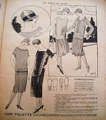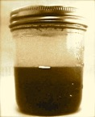

**Fashion Photo Dress Mud Masque**

Over the next week Ross and Margaret did several things. First, they gathered up old beauty pages from the paper to make a collage. Then they brought the big mirror up to the round house from the main house. Then they asked one of Ross’ aunts to make a flapper dress out of some of the pretty blue fabric from the round house that resembled the one in the newspapers and would fit Sheila. Then they made a mud masque that was full of minerals and good smelling lavender and honey. Ross even made Sheila a book to write in, similar to the one he used for his journal.



**Collage of Flapper Photos**

On Sunday, Margaret met with Sheila alone. She started by asking her to make a written list of all the things she didn’t like about herself. Sheila had a hard time putting her thoughts into words, so Margaret brought out the mirror. Sheila then pointed to a crooked eyebrow, a lopsided mouth, and a zit on her chin. She went on about how she felt ugly inside, too. Just not like other people.



**The Large Mirror**

Margaret then asked what she ate. This surprised Sheila but she answered quite plainly. It seems Sheila’s mother had died in the same manner that Margaret’s had—of pneumonia soon after giving birth— this had left Sheila to be the main cook in the house. The only thing she had really learned to cook was boiled water, so she and her two brothers and her father mostly ate rice and potatoes in the winter and vegetables and fruit from the garden in the summer.

Margaret realized this menu didn’t have any protein or a very wide variety of foods and that sometimes when people don’t get enough protein or a variety of foods they get very sad and feel moody. She thought that perhaps this might be part of Sheila’s problem, but she didn’t say this out loud. She only asked if Sheila might like to learn some of the recipes Meemaw had taught her. Sheila seemed excited, so they decided to start the following Sunday.

That first afternoon Margaret also asked Sheila to look very closely at the collage of photos they had made and tell her if she thought the women in the pictures were pretty. Sheila told her with enthusiasm that she did, and then Margaret and Ross together started pointing out that no person’s face is perfectly even, or perfectly perfect. Part of what made these pictures beautiful was that these women were dressed up; also they had make up on; and finally they were posing. They helped Sheila to identify the imperfections in every face in the collage.

When they had finished with the photos, Margaret took Sheila outside to look at the flowers, and Sheila discovered that every flower was different and beautiful in its own way and that some of the imperfections in the flowers were what made them beautiful. Margaret pointed out that the flowers and the women had this in common:, what was imperfect made them beautiful. Margaret reminded her that this was true for all people.

After that first week Sheila was feeling a bit better. After several cooking lessons over the next few weeks, Sheila knew how to combine rice and beans to make a complete protein and how to bake and follow a recipe, and pretty soon she was feeling more confident and better all around.

On the fifth week Ross and Margaret gave Sheila a complete makeover. In truth they didn’t make her over all the did was make a facial masque by mixing oatmeal, honey and an egg yolk, and applying it to Sheila’s face. Then washing Sheila’s hair in lavender soap and pinning her hair in curls. When they were through Ross’ Aunt brought out the dress she had made, and Sheila started to cry. Without a mother in the house, she had never had a dress made just for her.

Once she was dressed and her eyes were dry, Ross brought out the big mirror, and all at once Sheila understood that what they had been telling her all along was absolutely true. Everyone is beautiful in their own way, even her.

That very same night, Theo picked up Sheila for their second date. Although Theo had been anxious to continue dating Sheila after their first picnic date, Ross and Margaret had suggested that he wait until they were through working with her to ask her out again. Ross and Margaret understood that it is mighty difficult for Sheila to believe another person is attracted to her, when she doesn’t already feel attractive herself. Ross and Margaret wanted Sheila to have some time to learn to really see and feel her own beauty. Out of respect for what Ross and Margaret were trying to do, Theo waited until the lessons were complete to take Sheila on a second date.

So it was, on that very evening of the day that Sheila received the makeover and the new dress, Theo picked her up and took her downtown for dinner and to have their picture taken.



**Plattsburg Photography Studio**

Sheila had never had her picture taken before, and so she treasured that photograph and put it where she could see it everyday, for the rest of her life. That photograph served as Sheila’s reminder that beauty is something that requires only self-care and real beauty is in your heart. Letting go of hurtful thoughts and replacing them with happy ones takes a great deal of time and effort, though, so Sheila had to remind herself often for several years that even she is beautiful in her own way. Eventually Sheila grew to truly believe it, to know her beauty in her heart, and having that picture and all the support from Theo and Ross and Margaret made all the difference.

Chapter Fifteen

You Are What You Eat

(If You Want To Be Smart You Have To Fart)

That next spring there was a bumper crop of beans on the family farms in the Adirondack Mountains. Even Ross and Margaret found they had butter beans, kidney beans, and black-eyed peas coming out of their ears. Fortunately, Margaret knew how to boil them and put them into jars and seal them up to be used in the winter and Ross knew how to dry the beans so they could be bagged up to soak later in salty water and cooked. Margaret and Ross set to work each weekend putting up as many as they could, despite all their efforts they ended up eating many of them.



**Butter Beans Kidney Beans Black Eyed Peas**

Everyone in the town had the same problem with their bean crop that year. Well, you can probably imagine what happened: everyone started to fart. All around town, everywhere you went, you would hear sounds of people tooting to beat the band. And even though everyone knew why they were farting, they couldn’t help but laugh when they would hear one.

To try to encourage everyone to settle down, one of the town ministers even put a quote on the church board from the philosopher Hippocrates, whom he quoted as saying, “Passing gas is necessary to well-being.” But even though everyone knew that passing gas is natural and normal, they still found the farts very, very funny. That is until the cabbage started to come in.

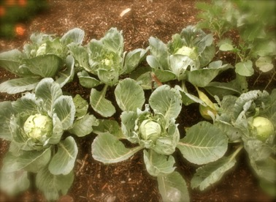

**Cabbage**

In addition to the extraordinary amount of beans that year the Adirondack Mountains harvested a spectacular amount of cabbage. Now, you can make cabbage into sauerkraut and can but there aren’t a whole lot of other uses for it, except to boil it up right away and eat it, or grate it and use it in coleslaw. This meant that besides the crazy amount of beans people were eating, they also consumed a great deal of cabbage that summer. This raised a whole new concern.

It turns out that cabbage makes farts stinky. Once the toots turned stinky, everyone started to rush to Ross and Margaret to find out what they could do. They didn’t want to waste all that good food, and yet they also didn’t want to be stinking themselves out of house and home. This is when Ross and Margaret researching what could be done.

Ross found out that while beans are full of fiber that is good for us, they also have sugars that are hard for a human body to digest. The reason the farts started to get stinky was because everybody was also eating cabbage, which has sulfur in it. When sulfur is burned up, it smells of rotten eggs, and so when a body tries to digest foods such as cabbage that contain sulfur, it makes gas that smells of rotten eggs.

Besides the problem with the smell of the farts, some people were also struggling with great aches and pains from the gas in their stomachs and intestines. Especially babies who were nursing on mothers who were eating the beans and cabbage would feel the ill effects and cry all day.

Margaret learned that a tea made from fennel seed could sooth a gassy stomach, and so she harvested the fennel in Meemaw’s garden and made large batches of tea for everyone. Ross realized that if people combined their beans with rice it would be easier to digest and would reduce the gas and if they didn’t ever eat beans and cabbage on the same day they could almost stop the smelly farts, and painful gas altogether.

In the end, the biggest problem became what to do with all the beans and cabbage they weren’t eating. That ended up being solved rather quickly by Ross’ brother Franklin, who without ever being asked, found a way to sell all the dried beans and fresh cabbage to Rhoulston’s Market in New York City.



**Roulston’s Market Advertisement**

What happened was that he saw an add for Roulston’s Market on a matchbook and impulsively hitched a ride on a barge down the Erie Canal from Lake Champlain.

When he got to New York, he talked to the manager at Roulston’s and gave him a free sample of the cabbage and beans. Franklin told the manager that he would come back the next day after he had a chance to try the beans and cabbage, and the man laughed and told him he didn’t have a kitchen to cook in, but could tell this was some good stock and bought the whole lot.

When he returned to town, Franklin had no trouble at all organizing everyone to ship their cabbage away. It took only about a week to arrange shipment of all the beans and cabbage on the barges headed to New York City.

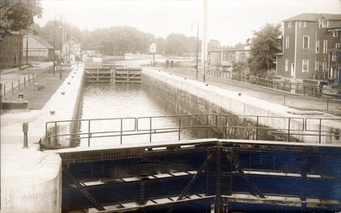

**A Lock in The Eerie Canal**

Even though everyone continued to joke about starting a tooting band and how you had to fart if you wanted to be smart, all were happy to be rid of the cause of their gas and to make some money to boot.

Franklin didn’t feel bad about selling the beans and cabbage to New York City, because the way he saw it New York was already a pretty smelly place.

Pretty soon the Adirondack woods was back to smelling as sweet fresh as usual.

Chapter Sixteen

If You Can’t Beat Em’ Join Em’

While Sundays were set aside as Ross and Margaret’s quiet time for “just being” in the round house, it wasn’t long before most of the other days of the week it was bustling with activity. At first it was Ross’s two youngest, older brothers, Marshal and Thomas, started bringing their friends over on Tuesdays after school. On Tuesday’s Margaret would set out snacks for them in the morning for them to enjoy in the afternoon. Snacks would include cookies or fruit and in the winter, the makings for hot chocolate in the fireplace. Her father was glad Ross’ family was enjoying the place so Tuesday afternoons would find him trudging over to the round house to start a fire so the place would be warm when the boys arrived. Ross and Margaret had no idea what they were doing in the house, but they sure seemed to have fun, and they never left a mess to clean up, so there was nothing to complain about.



**The Fireplace at the Round House**

It wasn’t long before one of Ross’ cousins had the same idea. Her name was Lena, and she was just a year ahead of Ross and Margaret. She used the round house on Wednesday’s to play cards with her friends. It was easy to accommodate them, as all Margaret had to do was make a double batch of whatever she was making the boys on Tuesdays and her father, who loved walking in the woods in the wintertime, only had to make a second fire. The girls were equally tidy and doubly appreciative.

The third group was a sewing group set up by one of the older girls at school. She had been searching for a place when Lena told her about the round house and Margaret said they would be happy to accommodate them on Mondays.

When this happened Ross and Margaret started thinking that perhaps they ought to form their own group. They settled on Thursdays, and they invited a group of friends from school to play games and “just be” together. They set about one Monday morning at school to invite Freddy, Miranda, Susan, Leo, Maria, Toby, Beth, and David. Ten seemed like a good size for a club because even numbers are always easier.

You get two people together and they rarely get into arguments; you get three people together and there is bound to be a fight. Margaret and Ross knew this to be true for everything from humans to wild animals. Two birds sing more sweetly than three. Two cats always get along better than three. And two friends get along better than three. Once there is an odd number there is always an odd man out.

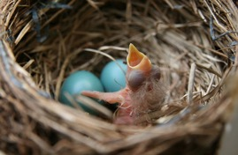

**Soon To Be Three Birds**

Margaret and Ross’ class at school was exactly 29 students, and there was always somebody who felt left out of something. So they decided on ten friends and quietly invited them.

Things went along easily for quite a while with the four groups sharing the space. The Monday group made a bunch of blue quilts to be used to keep everyone warm. The Tuesday brought in a bunch of games, and the Wednesday group built a shelf and organized the games. Ross and Margaret’s Thursday group only had to straighten pillows and things were right as rain for Monday again.

You would have thought that with an even number of groups things could go on like this for a long time, but the problem was that word got out that everyone was having such a good time that no matter how many were involved there were always a few more that wanted to be. Eventually, all of the groups just merged, and each afternoon whoever could come was invited to the clubhouse to sew or play games or relax or whatever.

Even with the new lackadaisical rules, Ross found one person from their school missing, and that was Bruce Cotter. Bruce was a great guy, and most of the time you wanted to hang out with him but every once in a while, when he didn’t get his way or you didn’t want to play the game he wanted to play, he would have a sort of whining fit. If you have ever heard a whining fit or had a whining fit then you already know that they aren’t much fun for the person having them or the person hearing them. Bruce himself probably would have liked to stop having whining fits, but he had them most of the time without even thinking about them.

So, it was after a couple of weeks of everyone being invited to the round house for some fun, Ross noticed there were no whining fits and that Bruce actually wasn’t there. He and Margaret thought long and hard about whether or not they should go out of their way to be sure that Bruce knew he was invited; knowing as they did that if he came there would be some uncomfortable moments. After considering a long list of pros and cons, they agreed that since the round house was now open for everybody’s use, it should be open to Bruce as well.

So it was that one Tuesday after school Ross and Margaret went to invite Bruce and, even though they probably shouldn’t have been, they were surprised by his reaction.

You see, Bruce had built his own clubhouse in the woods and when Ross and Margaret invited him to the round house he started a long line of complaining about nobody ever want to play with him. Naturally, the answer was that, because of his whining fits, everybody preferred to avoid him. But even amidst his whining and crying, Ross and Margaret felt sorry for him and agreed to go with him to see his house.

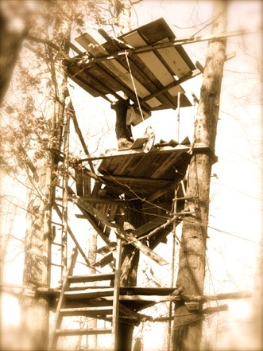

**Bruce’s Tree House**

They realized right away that there was another problem: the house that Bruce had built was hardly big enough for him and definitely wouldn’t have fit a large group. Not only that, but the structure itself was messy and not very sturdy and far up in a tree not at all the sort of house to use for a clubhouse for 10 or 20 kids.

Ross and Margaret tried to explain this to Bruce, but he would have none of it. He whined and complained and absolutely refused to hear a word they said. And so, quite calmly, Ross said, “Bruce, we would love it if you would come see our house sometime,” and Margaret added, “You are always welcome at the round house, and now that we know you have been invited, we are going to go.” And they both turned and started to leave. Immediately, Bruce started lamenting that nobody ever did what he wanted, that he always had to do what everyone else wanted, that his clubhouse was as good as any, and that nobody cared about him. At this, Ross and Margaret stopped, repeated their invitation calmly, and left without turning back.

When they got back home, neither one of them knew what to say. “He’s a bit old for such tantrums,” Ross said. Margaret agreed and added that she didn’t want to reward such behavior. So what did they do? For the first time since they met a problem, they just ignored it.

Now, nobody ever wants to be ignored, and, under most circumstances, ignoring can be considered quite rude. But when you are dealing with someone who has a fit whenever he doesn’t get his own way, well, there really are only two choices: you can ignore their outbursts, or you can join them. Naturally, not wanting to have a tantrum themselves, Ross and Margaret saw only one solution.

The other boys and girls who gathered at the round house agreed to follow Ross and Margaret’s example, so while they were pleasant and invited Bruce to join them, they didn’t budge an inch to see his tree house.

It wasn’t long before Bruce did start coming around to the round house, but instead of joining in he often sat outside crying. When people would ignore him he would do some dastardly things to get their attention. One time he relocated a pile of red ants to the door of the round house and Ross had to pick them up and move them down the hill.

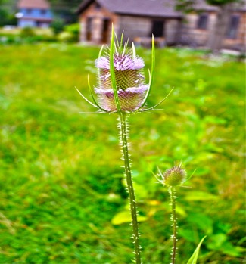

**A Prickly Thistle Plant**

Another time he took thistles and laid them out all along the ground hoping to plant the prickly plant all along the path. None of his plans worked and Ross and Margaret and the other kids just kept calmly inviting him now and then to join them in what they were doing. Bruce would always respond with a whine of, “Why won’t anyone ever do what I want to do? Boooo hooo hooo hoo.”

Sometime after the thistle planting attempt and after his antics had gone on one day too long for Margaret, she went out to Bruce and said, “Are you about done your whining?” And you know what? He was. From that day forward Bruce came over to the round house and helped with every activity that was going on. He found that he had even more fun going along with others than he did planning the whole thing, and he even learned to sew.

Some of the older boys saw the change in Bruce and wanted to do something to help him, and so, once he had stopped whining for a week and four days, the whole group of kids headed over to see his fort. Bruce was ashamed to admit to them that he had torn it down in a fit of disappointment. To his surprise, they all understood Bruce’s disappointment and appreciated his honesty and offered to help him rebuild his tree house better than it had been before. In that moment, Bruce realized that when you can’t beat them it really is better to join them, because if you join them, well, they might eventually join you.

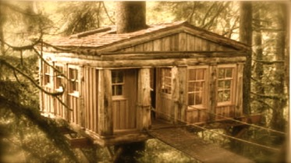

**Picture of Bruce’s New and Improved Tree House**

Chapter Seventeen

The Sixth Key

Margaret got into such a routine at Meemaw’s house that she rarely felt lonely anymore. There was so much to do: big gardens to tend, chickens and goats to feed, eggs and milk to harvest, canning to be done, honey to be gathered, salves to make. And Margaret and Ross had it down to a science.

Add to all that the comings and goings at the round house, and the increasing numbers of people asking for help to heal anything from poison ivy or pneumonia to bad behavior, and you know Margaret hardly had time to remember her life before Ross and Meemaw, let alone to miss it in any way.

After four seasons of the routine at Meemaw’s place, Margaret only had a vague recollection of how lonely her life had been. That is until one autumn day when her father mentioned the tamarack tree.

While Hiram had become comfortable at Meemaw’s house, he did not exactly feel at home. He missed some of the quirks of his old house. The way the shutters would squeak in the wind, the way the first step would sound like it was talking to you when you would walk in. Most of all he missed the tamarack tree. He wondered if Margaret even remembered it and so one afternoon he asked straight out “Margaret, do you remember that tamarack tree?” and when she nodded, he said, “I wonder how big it has gotten.”

Margaret and Ross and Hiram decided to take a walk over to the old house, see what Ross’ cousin and his wife were doing, and check on the old tamarack tree. First Margaret made an apple pie because it is always good to take something to friends when you go for a visit, and it is especially good to take something as tasty as a pie.

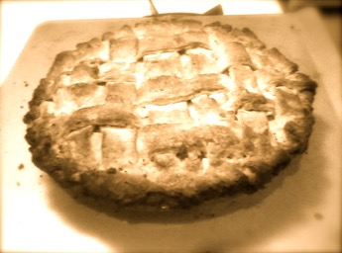

**Margaret’s Apple Pie**

When they arrived at the house they were surprised to find that the tamarack tree had grown about 8 inches since they had left. It had filled out quite a bit, too. Margaret wondered if her old friend missed her, but she felt funny about saying hello to the tamarack tree in front of Ross and her father.

Ross was immediately surprised that Margaret and Hiram were paying so much attention to the Tamarack. “Wow, you have a Tamarack tree too!” he said with surprise.

“What do you mean, too?” Hiram questioned. And so Ross told them the story that on the day he was born his father had planted a Tamarack tree at his house. Hiram laughed to hear this and shared that he had planted *this* tamarack on the day that Margaret was born.

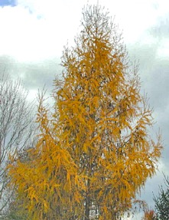

**Margaret’s Growing Tamarack Tree**

Margaret’s father explained that Tamarack wood is very flexible and very good for making anything with curves, such as snowshoes and bentwood chairs and beds. He and Maggie had dreamed of growing a whole grove of Tamarack trees and he wanted to build furniture out of them as a side business.

When they knocked on the door of their old home Ross’ cousins’ welcomed them inside. Margaret gave them the pie and Hiram complimented all the lovely changes they had made. The pictures they had hung on the walls and the way they rearranged the kitchen had made the house into their home. He asked their permission to move the Tamarack up to Meemaw’s house, and it was agreed. And then he asked if he could show Ross and Margaret the bed in the guest room.

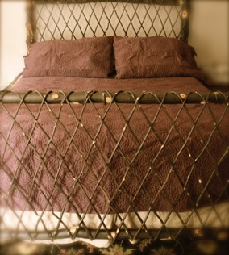

**Tamarack Bed**

Hiram explained that he made the bed from a tamarack tree that he had found in the woods behind his parents house. It was so pretty with crisscrossed branches at the head and foot of the bed. He asked Ross and Margaret if they might want to put a tamarack grove somewhere on Meemaw’s land. He promised to teach them how to make furniture (something he had learned from his father). They agreed, and a plan was made to dig up Margaret’s Tamarack and bring it to Meemaw’s house.

The funny thing was that when they dug up the tree they noticed just beside it a patch of mullen growing. Mullen is a beautiful plant that grows naturally where earth has been disturbed. Margaret had read about it in books but she had never seen it. She explained to everyone that mullen was sacred to the native people in the Adirondack’s and that they used it to make a tea to use when someone had a cold with fluid in their chest or lungs.

Ross, who was always harvesting the herbs that Margaret needed, asked if she wanted to gather some up and bring some up to Meemaw’s as well. She thought that was a good idea. Margaret started to wonder who would have turned over this piece of land and for what purpose?

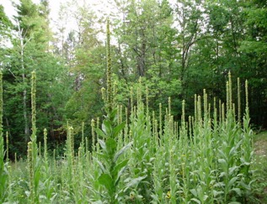

**Mullen Patch beside the Tamarack Tree**

Ross and Hiram had wondered the same thing. And so, while Ross began to dig around and pull up the mullen for replanting, he also dug around to see if he could find out what turned over the earth in that area.

He didn’t have to dig too far before he find out. A small, locked wooden box was sitting beneath the soil where the largest amount of Mullen was found. It was very dirty, but they dusted it off and placed it carefully in the wheel burrow with the Mullen and Tamarack tree and took it home.

Once home, Margaret chose a place close to the house for her tamarack tree and then she and Ross and Hiram choose the field to begin the Tamarack grove, and then they turned their attention to the box. Who could have put that box there? What could be in that box? How long ago was it placed there? Where is the key that opens it? The box was made of wood so they could break it, but Margaret didn’t want to because it was so pretty.

Oh what to do what to do? They just couldn’t decide. If they broke the box and there was nothing in it they would ruin a perfectly wonderful box. But what were the chances they could find the key? And the biggest mystery of all was who would have put this box there on their property to begin with.

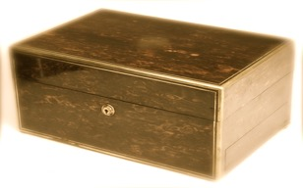

**The Locked Box Found Under the Mullen**

Looking closely at the box they found a small spot where it looked as if someone had rubbed off some initials. There was gold paint along the edges and a dark brown stain all over the box. Margaret cleaned it carefully and then rubbed it with oil and it shined in the noonday sun. They decided to give it some time and to look for the key.

After that, Ross and Margaret headed up the round house for their usual Sunday “just being” time and were surprised at how many people stopped in to ask for some help.

The first person who stopped by was a mother and son. The mother walked in the door complaining that her son never listened to her. Ross guided the mother upstairs and listened carefully to what she had to say while Margaret took the son outside to sit in the small garden to hear what he had to say. This is the way they often handled conflicts. It is always good to listen to people when they are upset; it helps them to calm down.

The mother explained that her husband had died soon after her son was born and that she felt overwhelmed with taking care of him alone. Ever since he was two, she felt as if the only word out of his mouth was “No.” She would say, “ I want you to take the trash out,” and he would say “No.” She would say, “It is time to go to school” and he would say, “No.” No matter how simple the request, no matter how much he even might like to do it, her son would say, ‘No.’

Margaret heard a similar but different story from the son. He said that ever since his father died he felt as if his mother expected him to be the man of the family. She asked him to do all of the chores, and he never had any fun. He felt angry that he didn’t have a father to take care of things and frustrated that his mother didn’t give him any time to play or do anything fun.

After Ross and Margaret listened to them individually they brought them back together and suggested they tell the same things to each other. Talking to each other was a bit harder than talking to a stranger, but they managed it with some help from Ross and Margaret. When they were through they were actually hugging and promising to listen to each other. The mother promised to play more, and the boy promised to help more.

“That seemed simple,” Ross said to Margaret when those two left.

“True listening with an open heart is never simple,” Margaret replied.

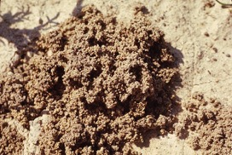

**Ground Bees Nest**

The next group that came in were three small boys who had been out playing in the woods and stepped on a ground bees nest. They were all stung up and hurting. Fortunately for them, they, were near the round house when it happened, so they stopped in for a remedy.

Ross quickly mixed up some baking soda and water, and then Ross and Margaret quickly put small patches of the mixture on each of the ground bee bites. The boys immediately felt some relief, thanked Ross and Margaret and went back out to play.

The final visitor to the round house that day was the strangest of all. He was a 56-year-old hermit named David. A hermit is a person who likes to live by himself, and as such, Ross and Margaret had never seen their neighbor David, even though they passed his dwelling place every day on the way to school.

David knew all about them, however, because David, although rarely seen, was always listening. In all the comings and goings beside his small shelter, he had heard of the healing young people and always knew where he was going to go if he had a problem. And that day he had a problem.

Leroy had bronchitis, which basically is an infection in the lungs. He knew he had it because he was having trouble breathing, and when he would cough green slimy thick gunk would come up. He had tried for about a week to clear this up for himself with no luck at all before deciding to go see Ross and Margaret.

Ross put his head next to Leroy’s chest and listened to his lungs and knew right away that they needed the mullen they had just dug up at Margaret’s old house. He knew he could burn it as incense as well as and mix it in a tea to help clean David’s lungs. Hearing this, Margaret decided to go into the pie safe that sat in the corner and gather some already dried mint and Echinacea to add to the tea.

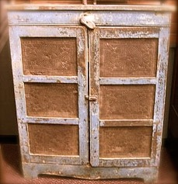

**The Pie Safe in the Round House**

Sitting on top of the pie safe was the ring of six keys the robin had pointed out nearly a year ago. 6 keys and 5 doors she had never for a day since then wondered where that sixth key went, and now she thought she knew.

Once Ross had gathered and prepared the mullen Margaret put some of it in bowl they used to burn incense and let it do its magic while they brewed the tea. David breathed in the sweet sticky smoky air in the quiet of the round house and it wasn’t long before he felt some relief.

Once David had left the round house Ross and Margaret took a good look at the keys. Six keys and five locks, maybe that sixth key could open the wooden box. They quickly straightened up and headed back to Meemaw’s house to check out the box.

And you know what? The key fit. Since Hiram had been there when they had found the box, Ross and Margaret thought they should wait until he could be there to see what was inside.

While they waited for him they talked about their day. What an amazing day they had. Margaret felt closer to her father and her family after seeing the house again. Ross was amazed that both of their parents had planted a tamarack tree on the same day. And what were the chances that someone who came to the round house for a cure that day would need the mullen they had just gathered?

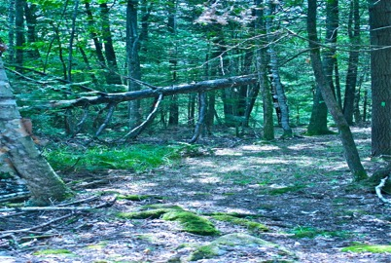

**Adirondack Woods**

Chapter Eighteen

The Not So Secret Nature Healing Shop

When Hiram came home they opened up the box, and do you know what they found inside? Another key! And another note from Meemaw! This note was shorter. It read:

Dear Precious Ones,

I am hoping you have by now moved into my house, and found the round house. I put this box here because I know your healing abilities and I figured by now you might need a real space to meet with people in the open. That is why there is another key in this box. This key is to an empty shop at 11 Main Street. When you find it, you will notice it has a blue door. I hope you will find some help around the farm so you can devote more of your energies to the healing you were born to do. As always and forever, I love you very, very much and I am with you every step of the way.

Love, Love, Love, Always. Meemaw

Ross and Margaret were astonished. How had Meemaw known they were healers? How had she known that they would need a place other than the Round House to help people? How had she known that they would dig up the mullen patch at Margaret’s house? It had been more than two years since she had died and here a note from her had just emerged. It was late and Ross needed to go home, so they decided all the answers would need to wait until the next day. That night, Ross and Margaret and Hiram each had dreams about Meemaw and the new shop.

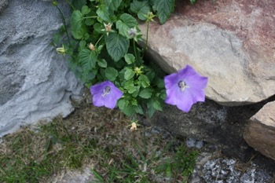

**Purple Flowers in Meemaw’s Garden**

Margaret dreamt of Meemaw leading her through the shop pointing out where to put all the important ingredients. In the dream, Meemaw taught her to make tinctures again and taught her to mix Echinacea with boiled grape juice to stop a fever. Meemaw also explained that the shop had a blue door and purple shelves the color of the flowers in her garden, because they are healing colors that would help her meditations between patients. Even while Margaret dreamt, she wasn’t quite sure what Meemaw meant, but she was certain that she would figure it out eventually. In the last part of Margaret’s dream, Meemaw showed her that the shelves were stocked full of all the ingredients she and Ross needed to heal any type of illness and told her not to worry, that they already knew everything they would ever need to help someone heal into wholeness.

Hiram dreamt that people came from all over to get amazing cures from Ross and Margaret. He saw a train coming through their town from New York City bringing people to the Adirondacks to breathe the extra clean air and to find a cure for whatever ailed them, and Ross and Margaret’s was the first place they stopped. In his dream there was a large grove of tamarack trees on the property and he made furniture that he shipped to New York City on the trains and barges.



**Hiram’s Tamarack Grove**

Ross dreamt that they set up the shop to do cures, and the first person that came in had blue skin. In his dream the blue man was full of some toxic poison he had given to himself to try to heal some sort of sickness on his own. In Ross’ dream, Meemaw suggested that they try to detoxify him with a tea of mint, ginger, burdock root, lime juice, and cayenne pepper. At the end of his dream, Meemaw gave Ross a hug and told him how proud of him she was and how much she hoped he was proud of himself. She took a pebble and threw it into a pond. They both stood and looked at the ripples and then Meemaw said, “Everything in life starts with one drop and then is spread out in ripples. Always remember to live every drop and every ripple to it’s fullest. I know you are working to do just that and I love you for that.” And with that she gave him a kiss and faded with the dream.



**Ripples on the Water**

The next day was Monday, and Ross and Margaret had to go to school. Hiram promised to meet them after school and walk with them downtown to find the storefront. Ross and Margaret were terribly distracted during school; they couldn’t get their minds off the mystery box and the shop.

As usual, their friend Freddy was the first to notice their distraction. “Is something happening this afternoon at the round house?” he asked. They both shook their heads “no” and so he persisted with more questions until they told him what was going on.

When their other friends heard, they all gathered around and peppered them with questions. How did two kids get a shop? What were they going to do with it? What did it look like? How were they going to run a shop and keep the round house club going and do all their chores? Were they still going to come to school?

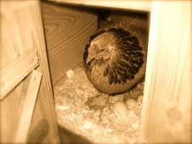

**Taking Care of Chickens Takes**

**Four to Five Hours Per Week**

Ross and Margaret realized at once that they were going to need their friends help. They asked Freddy (who had long since given up his bully ways) if he would keep up the round house activities going for them, and he agreed. And Sheila, who had learned to be quite a good cook, offered to keep the snacks coming to the round house and the new shop. Even Bruce, who had never volunteered to help another person do anything, jumped in offering to help care for the animals on Meemaw’s farm so that Ross and Margaret could have more time to prepare their salves and tinctures.

With all the promises of help, Ross and Margaret were certain that they would be able to keep coming to school on weekdays and on Monday and Wednesday after school and Saturdays, after chores, to keep the shop open on Main Street.

At long last, the school day was over. Hiram was waiting outside, and they walked down Main Street looking for the shop. Hiram knew it as soon as he saw it, because he remembered buying honey and salves there when he was a boy. Hiram figured the shop had only been open when Meemaw’s husband was alive, which meant the shop had been closed up for over two decades.



**The New Magical Healing Shop**

Ross’s grandfather’s family ran a small grocery store in that exact location. When he was near retirement age, a larger grocery store opened up down the street and, instead of selling his store or passing it on to one of his children, he just closed up shop.

Hiram remembered that on the his last day the old grocery was open, all of Ross’ grandfather’s longtime customers lined up down the street to say goodbye to him. Many of them brought him gifts such as pies they made or things they had canned out of the produce they had bought at his store. Some of them brought cards or things they had made for him to say thank you.

Hiram’s mother had baked some special apple bread that day, and 9 year-old Hiram waited 2 hours in line with his mother to deliver it to Ross’ grandfather to say thank you.

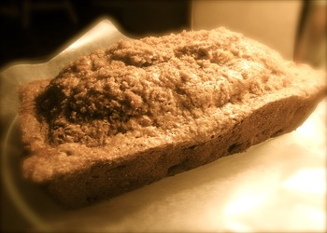

**Hiram’s Mother’s Apple Bread**

As they approached the shop, Margaret marveled at the amazing cobalt blue tiles over the doorframe and the deep lavender color of the shelves inside. It was just like her dream, and even though there were no medicines in place on the shelf, because of her dream, she felt she knew just where they needed to go.

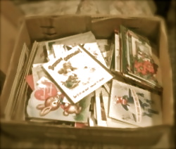

**Box of Ross’ Grandfather’s Cards**

Ross found the cards that were written for his grandfather on the day the shop closed. He and Hiram were both surprised that the date the shop had closed was November 11, 1900, exactly 11 years before the day Ross and Margaret were born. Hiram pointed out how strange it was that the number 11 kept popping up over and over in Ross and Margaret’s lives. Ross smiled and said it seemed like a sign of good luck.

After they had swept the twenty-two years of cobwebs off the shelves, Margaret began to mark each shelf with what she remembered from her dream should be there. Ross began to make a large sign that read, “The Super Nature Healing Shop” to put over the door.

Margaret laughed when she saw the sign and remarked, “We sure have come a long way since I tripped over you that first day of school in the woods.” Ross laughed as she said it, and they both laughed as they did their secret handshake they had made up eleven years before. It is a secret handshake so it is difficult to tell how many knuckle pops and elbow bumps are involved but when they were through everyone in the shop that day was laughing along with them.

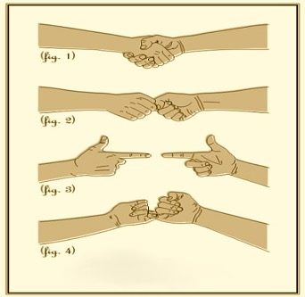

**A Secret Handshake**

It was hard not to smile and laugh because Ross and Margaret just made everything seem more fun and made everyone want to participate.

The magical nature of real friendship is a hard thing to describe, but Ross and Margaret had bucket loads of it from the first time they met. Theirs is the kind of friendship that encourages each of them to be the best person they can be and in turn encourages everyone around them to also be the best people they can be. It is not an exclusive kind of friendship that leaves anyone out, it is the kind of inclusive friendship that pulls everyone in.

Even Bruce and Freddy, who at one time had begrudged Ross and Margaret’s secrets, now understood now that special friends need something all their own sometimes. When they saw Ross and Margaret doing their secret handshake both laughed along with everyone else and turned to each other and came up their own secret handshake.

It was starting to get dark as they headed out of the shop that day. Ross and Margaret thanked everyone for their help, and all their friends left the shop with them and headed down Main Street feeling excited about all that the new Shop was going to offer.

As they rounded to the field that separated all of their homes, Miranda pointed out the lightening bugs that had gathered in the tall grasses.

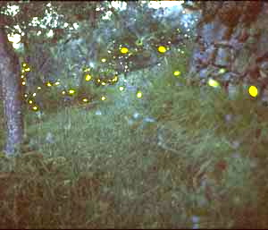

**Lightening Bugs on the Path Home**

Everyone stopped to watch the magic of the yellowish green lights darting in and out of the grasses. Lightning bugs (or fireflies if that’s what you call them) are quite amazing little bugs. They show up to announce the onset of summer and brighten pathways and lighten hearts wherever they go.

Without a word, all of the children started dancing with the fireflies. It was a glorious early summer night, and Ross and Margaret knew where they were supposed to be and what they were supposed to be doing. All seemed right with their world

Recipes that Meemaw Taught To Margaret

Popovers

Ingredients: Two cupfuls of milk, two cupfuls of flour, two eggs, two Tablespoon butter, and an even teaspoon full of salt., two more tablespoons of butter for the pan.

Instructions: Separate the yellows from the whites of the eggs and beat separately. Beat the whites until stiff. Mix the yellows with the milk and flour and butter and salt. Last add the whites and mix lightly. Put a dab of butter in each muffin tin and put in the back of the oven to melt. Carefully remove the hot buttered muffin tin and fill each tin half full with popover dough. Bake in the oven of 450 degrees for 15 minutes and then turn the oven down to 350 and bake for 30 more minutes, until lightly brown. Take out and dump the pan immediately. Serve with butter and honey, maple syrup and jam.

Scones

Ingredients: 3 cups of flour, a pinch of salt, half a teaspoonful of baking soda, 1 heaped teaspoonful cream of tartar, 1 tablespoonful of butter, 2 cups of milk.

Instructions: Put the flour, salt, cream of tartar, and baking soda into a bowl; rub the butter into the flour with the tips of the fingers; make a well in the centre and pour all the milk in at once. Add nuts or berries as desired. Turn out on to a slightly floured board and knead as lightly as possible; press out with the palm of the hand into a cake; brush over with an egg yolk; cut into neat triangles, and place on a hot tin in a 400 degree oven for fifteen minutes. Roll in cloth till cool.

Buckwheet pancakes

Ingredients: Two cups boiling water, a cup of fine corn meal, a pinch of salt, half cup white flour, one cup buckwheat flour, one fourth cup yeast, one teaspoon baking soda.

Instructions: Pour boiling water over corn meal and salt. Mix well, when lukewarm add white flour, buckwheat flour and yeast and baking soda. Beat till smooth. Let rise. Fry in large rounds and serve with butter and honey, maple syrup or jam.

Chicken Soup with Ginger and Garlic

Ingredients: 1 Tablespoons Oil, 8 wild red onions (or one large red onion), 1 rib celery, 3 carrots, 2 Cups Broccoli Crowns, 6 cloves garlic, 3 pinches salt, 8 cups chicken Broth, 2 Tablespoon ginger root grated, 1 Tablespoon thyme leaves, 1 Tablespoon Rosemary leaves, 2 cups cooked chicken chunks, 2 Tablespoons scallions.

Instructions: Heat oil in a soup pot over medium heat.   
Add the onion, celery, carrots and garlic and cook for about 5 minutes, until the onion runs clear. In a separate bowl mix the stock with salt, ginger, garlic, thyme, and Rosemary. Bring to a boil, and then simmer 20 minutes over low flame. Add chicken and heat through. Ladle the soup into bowls and top with scallions.

Gingerbread

Ingredients: ½ cup Brown sugar, ¼ cup molasses, ¼ cup butter, 1 egg, 1 ½ cup whole wheat flour, ½ cup buttermilk, 1 tsp baking soda, 1 tsp ginger, ½ tsp cinnamon

Instructions: Cream sugar, molasses, and butter together. Beat in egg. Mix spices with the flour and add alternately with the buttermilk and soda. Pour into a buttered cake pan. Bake at 350 degrees for 25-30 minutes or until cake springs back to light touch.

Anadama Bread

Ingredients: ¾ cup boiling water,

½ cup yellow cornmeal 3 Tablespoons shortening ,

¼ cup light molasses , 2 tsp salt, 2 Tablespoons yeast , ¼ cup warm water, 1 egg, beaten   
2¾ cups unbleached bread flour.

Instructions: Stir together boiling water, cornmeal, shortening, molasses, and salt. Cool to lukewarm. Sprinkle yeast on warm water; stir to dissolve. Add yeast, egg, and 1¼ cups flour to cornmeal mixture. Beat together. With a spoon, beat and stir in remaining flour until batter is smooth. Grease a loaf pan and sprinkle with a little cornmeal and salt. Spread batter in pan. Cover and let rise until batter just reaches the top of the pan, about 1½ hours. Bake at 375 degrees for 25 to 35 minutes or until done. Remove from pan and cool on rack before serving.

Buttermilk Pie

Ingredients: 4 eggs, 1 teaspoon vanilla extract,  2/3 cup buttermilk, 2 Tablespoons flour  
            2 cups sugar, ½ cup melted butter, pie crust.

Instructions: First mix eggs, vanilla, buttermilk then add the flour and sugar, and the melted butter. Pour into an un-baked pie shell. Bake at 350 degrees for 45-55 minutes.

Rhubarb Pie

Ingredients :4-5 cups chopped rhubarb, 2 cups sugar, 3 Tablespoons flour, 1 teaspoon cinnamon, 1 teaspoon vanilla extract, 3 tablespoons butter cubed, 1 egg white beaten

Instructions: Mix the chopped rhubarb, sugar, flour, dash of cinnamon, and vanilla. Mix well in a large bowl and pour out into chilled crust. Dot the top of the filling with the butter. Roll out the other piece of pie crust and place over filling. Crimp to seal edges. Cut holes in the top crust. Bake at 375 degrees F and bake for a additional 50 to 65 minutes, or until the filling starts bubbling and seems thick.

‘

Pie Crust

Ingredients: 2-½ cups flour, 1 cup butter or lard,

Dash of salt, 3 Tablespoons Sugar,

1 tablespoon vinegar,

½– ¾ cup milk

Instructions: Combine flour and lard and mix well. In a separate bowl combine salt and vinegar to milk and stir. Combine milk mixture with flour and lard. Blend; shape into a ball and chill for 2 hours. Roll out on a floured board.

Pound Cake

Ingredients: A pound of fresh unsalted butter, a pound of sugar, nine eggs, 1 teaspoon vanilla,

2 teaspoons lemon rind, 1 pound flour

Instructions: Cream the butter with the sugar till it is very smooth. beat the egg whites and yolks separately and add them bit by bit to the butter and sugar. Bake at 325 degrees for about 90 minutes.

Baked Beans

Ingredients: 1 pound dried red beans, 1 quart water, 1/2 teaspoon salt, 1 medium onion, chopped, 2 tablespoons mustard, 2 tablespoons brown sugar, 2 tablespoons dark molasses, 1/2 pound sliced bacon, cooked and crumbled

Instructions: Place beans in a Dutch oven add enough water to cover by 2 inches. Bring to a boil; boil for 2 minutes. Remove from the heat; cover and let stand for 1 hour. Drain and rinse beans, discarding liquid. Return beans to pan. Add water and salt; bring to a boil. Reduce heat; cover and simmer for 1 to 1-1/4 hours or until beans are tender. Drain, reserving 2 cups cooking liquid. In a greased baking dish, combine all the ingredients and reserved cooking liquid. Cover and bake at 400 degrees for 45 minutes or until beans have reached desired thickness. stirring occasionally.

Taffy

Ingredients: 3 pounds of sugar and half a pint of water and flavoring of your choice.

Instructions: Boil sugar and water over slow fire for half of an hour, when thickening, rub hands with butter and pull, twist or braid and cut in strips. Let harden.